Supplementary materials:

The role of nocturnal and diurnal pollinators in the commercial production of Dragon Fruit crops in Costa Rica

Jordán Villegas-Murillo & Mauricio Fernández Otárola
*Correspondence: mauricio.fernandez@ucr.ac.cr

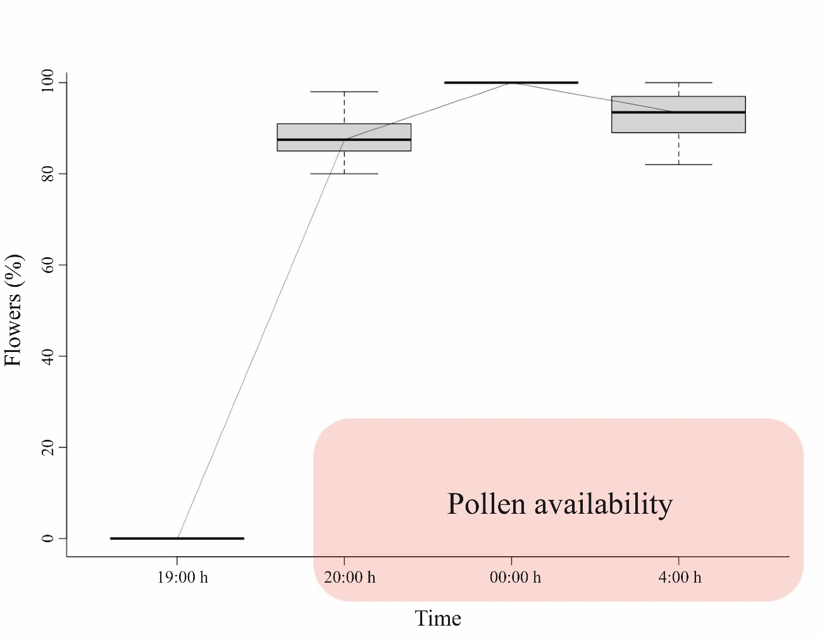
Fig. S1. Stigmatic receptivity according to the moment of the night during the massive flowering events (n=315 for 19:00 h, 20:00 h, and 4:00 h; n=290 for midnight). The boxes represent the interquartile range, the horizontal line of the box represents the median, and the whiskers represent the 98% distribution of the data. The pink box represents the interval where pollen is available for pollination.

Table S1. Spatiotemporal context of the sampling nights. The number of sampled nights is indicated. Times are in CST.
 | Sampling
Plantation | 2019 |  |  | 2020
 | June | September |  | May | July | August
Curubandé | 2 | - |  | - | - | -
Atenas | - | 1 |  | 1 | 2 | -
El Salto | - | - |  | - | - | 2
Sunset* | 18:02 | 17:31 |  | 17:50 | 18:01 | 18:00
Sunrise* | 5:18 | 5:26 |  | 5:17 | 5:27 | 5:32

Table S2. The specimens collected and identified as floral visitors of H. costaricensis. Daytime (D), evening (E), nighttime (N), and early morning (M).
* M. rustica probably.
Order | Family | Taxon | Site | Period
Coleoptera | Cantharidae | sp.1 | Atenas | D
 |  | sp.2 | Atenas | D
 | Chrysomelidae | Eumolpinae sp.1 | Curubandé | D
 |  | Eumolpinae sp.2 | Atenas | D
 |  | Galerucinae sp.1 | El Salto | E
 |  | Galerucinae sp.2 | Atenas | E
 | Nitidulidae | sp.1 | Curubandé | N
 |  | sp.2 | Atenas | N
 |  | sp.3 | Atenas | N
 |  | sp.4 | Atenas | N
 | Scarabaeidae | Cyclocephala sp. | Curubandé | N
 |  | Rutelinae sp.1 | Atenas | E,N
 |  | Rutelinae sp.2 | Atenas | E,N
 |  | Scarabaeinae sp.1 | Curubandé | E,N
 |  | Scarabaeinae sp.2 | El Salto | N
Diptera | Muscidae | sp.1 | Atenas | E
 | Sarcophagidae | sp.1 | Atenas | E
Hemiptera | Cixiidae | sp.1 | Atenas | N
Hymenoptera | Apidae | Apis mellifera | All sites | M
 |  | Cephalotrigona zexmeniae | Atenas | E
 |  | Melipona beecheii | Curubandé | M
 |  | Partamona orizabaensis | Atenas | M
 |  | Trigona corvina | Atenas | E
 |  | Trigona silvestriana | Atenas | E
 |  | Xylocopa fimbriata | Curubandé | N,M
 |  | Xylocopa c.f. gualanensis | Curubandé | N,M
 | Halictidae | Agapostemon texanus | Curubandé | N
 |  | Augochlora sidaefoliae | Curubandé | N
 |  | Caenaugochlora costaricensis | Curubandé | N
 |  | Megalopta amoena | Curubandé, El Salto | N
 | Ichneumonidae | Ophion sp. | Atenas | N
 | Vespidae | Agelaia centralis | Atenas | M
Lepidoptera | Sphingidae | Manduca rustica | Curubandé, El Salto* | N

