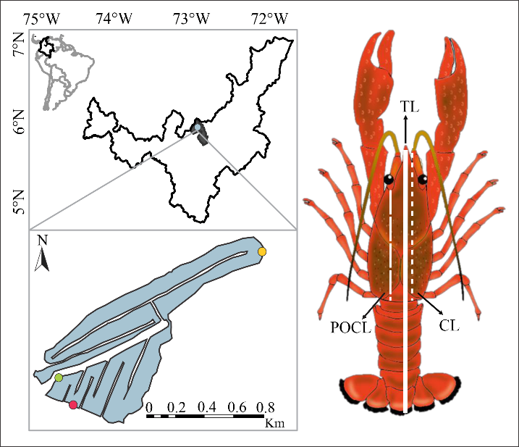
SMF 1. Study area and measurements taken of Procambarus clarkii. TL: Total length. CL: Carapace length. POCL: Postorbital carapace length. Pink spot: P. punctatum, green spot: J. effusus, yellow spot: L. peruviana.

SMT 1
Physicochemical parameters of water in the macrophyte transects from the study area
Month | Macrophyte species | Temperature (°C) | Conductivity (µS/cm) | Dissolved Oxygen (mg/L) | pH | Substrate
May | Juncus effusus | 19.00 | 130.10 | 9.10 | 7.51 | Clayey
 | Ludwigia peruviana | 20.00 | 139.20 | 8.48 | 9.96 | Stony
 | Polygonum punctatum | 20.00 | 138.80 | 7.54 | 8.01 | Muddy
July | Juncus effusus | 15.60 | 160.10 | 1.47 | 7.00 | Clayey
 | Ludwigia peruviana | 19.90 | 153.90 | 3.83 | 9.03 | Stony
 | Polygonum punctatum | 16.00 | 161.40 | 1.44 | 7.03 | Muddy
September | Juncus effusus | 20.60 | 164.40 | 2.04 | 6.80 | Clayey
 | Ludwigia peruviana | 20.10 | 161.80 | 1.94 | 6.93 | Stony
 | Polygonum punctatum | 19.10 | 160.60 | 1.50 | 6.90 | Muddy
November | Juncus effusus | 20.90 | 152.60 | 2.69 | 7.06 | Clayey
 | Ludwigia peruviana | 20.10 | 151.06 | 2.21 | 6.92 | Stony
 | Polygonum punctatum | 20.00 | 152.40 | 2.12 | 7.39 | Muddy

SMT 2
Morphometry of Procambarus clarkii specimens evaluated in the study
Description |  | Weight (gr) |  | Total length (mm) |  | POCL (mm) |  | Carapace length (mm)
 | N°  indiv. | Rank | Mean±des | Rank | Mean±des | Rank | Mean±des | Rank | Mean±des
Juncus effusus | 80 | 1.1-25.7 | 11±5.9 | 40.5-106.1 | 78.2±14.4 | 14.1-41.3 | 28.9±6 | 17.9-54.6 | 38.7±7.6
May | 34 | 1.1-22.2 | 9.2±5.0 | 40.5-99.7 | 74.0±14.4 | 14.1-37.9 | 27.3±5.9 | 17.9-50.8 | 36.5±7.8
Female | 12 | 2.0-15.6 | 7.4±4.5.0 | 48.2-90.9 | 69.4±13.3 | 16.1-34.3 | 25±5.6 | 22.6-45.0 | 33.9±7.0
Male | 22 | 1.1-22.2 | 10.2±5.1 | 40.5-99.7 | 76.5±14.7 | 14.1-37.9 | 28.5±5.9 | 17.9-50.8 | 38.0±7.9
Jul | 17 | 4.7-24.5 | 11.7±5.5 | 61.9-105.2 | 79.8±11.7 | 22.7-38.0 | 29.7±4.5 | 31.1-50.3 | 39.1±5.5
Female | 7 | 5.0-24.5 | 12.8±6.7 | 62.5-105.2 | 81.5±13.9 | 22.7-38.0 | 30.3±5.2 | 31.2-50.3 | 39.8±6.5
Male | 10 | 4.7-20.1 | 10.9±4.8 | 61.9-94.2 | 78.7±10.5 | 23.4-36.6 | 29.2±4.1 | 31.1-47.0 | 38.6±5.0
Sep | 16 | 4.7-23.4 | 12.5±5.4 | 62.3-106.1 | 83.2±11.5 | 22.1-41.3 | 31.0±5.1 | 30.1-54.6 | 41.7±6.3
Female | 9 | 4.7-23.4 | 13.6±6.5 | 62.3-106.1 | 85.1±14 | 22.1-41.3 | 31.8±6.1 | 30.1-54.6 | 42.7±7.7
Male | 7 | 6.7-18.0 | 11.0±3.6 | 70.9-94.8 | 80.9±7.7 | 25.1-36.7 | 30.0±3.7 | 35.6-47.4 | 40.4±3.9
Nov | 13 | 2.0-25.7 | 12.7±8.1 | 48.7-105.1 | 81.2±18.5 | 15.8-39.4 | 29.3±8.2 | 23.4-51.9 | 40.1±9.8
Female | 11 | 2.0-25.7 | 12.6±7.9 | 48.7-105.1 | 81.3±18.6 | 15.8-39.4 | 29.4±8.3 | 23.4-51.9 | 40.4±9.7
Male | 2 | 4.1-21.9 | 13.0±12.6 | 61.8-98.6 | 80.2±26.0 | 21.2-36.7 | 28.9±11 | 28.7-49.0 | 38.9±14.4
Ludwigia peruviana | 138 | 0.01-23.1 | 8.0±6.3 | 11.6-153.6 | 65.9±25.1 | 4.4-40.9 | 24.3±9.4 | 6.1-54.2 | 32.5±12.2
May | 4 | 4.1-15.7 | 9.3±5.8 | 57.5-85.9 | 71.2±15.3 | 20.6-34.9 | 27.1±7.0 | 28.3-45.6 | 36.4±8.5
Female | 2 | 4.5-12.7 | 8.6±5.8 | 58.6-82.9 | 70.8±17.2 | 21.9-31.1 | 26.5±6.5 | 30.2-41.7 | 35.9±8.1
Male | 2 | 4.1-15.7 | 9.9±8.2 | 57.5-85.9 | 71.7±20.1 | 20.6-34.9 | 27.7±10.1 | 28.3-45.6 | 37±12.3
Jul | 70 | 0.7-20.2 | 6.4±6.3 | 11.6-100.6 | 57.2±25.4 | 4.4-36.8 | 21.2±9.9 | 6.1-48.5 | 28.2±12.7
Female | 34 | 0.7-20.2 | 7.6±7.3 | 17.7-100.6 | 59.1±28.8 | 6.2-36.8 | 22±11.4 | 8.7-48.5 | 29.4±14.3
Indeterminate | 1 | 0.01-0.01 | 0.01±0.0 | 11.6-11.6 | 11.6±0.0 | 4.4-4.4 | 4.4±0.0 | 6.1-6.1 | 6.1±0.0
Male | 35 | 0.2-18.6 | 5.4±4.9 | 17.9-94.5 | 56.7±20.8 | 6.8-36 | 20.9±8 | 7.6-47.4 | 27.7±10.6
Sep | 62 | 0.3-23.1 | 9.6±5.9 | 22.0-153.6 | 74.5±22.3 | 8.2-40.9 | 27.4±7.9 | 11-54.2 | 36.7±10.1
Female | 39 | 0.3-19.6 | 8.9±6.0 | 22.0-101.5 | 70.3±21.2 | 8.2-38.8 | 25.8±8.3 | 11-50.9 | 34.9±10.6
Male | 23 | 0.3-23.1 | 10.9±5.6 | 22.2-153.6 | 81.7±22.7 | 9.0-40.9 | 30.1±6.5 | 11.4-54.2 | 39.9±8.5
Nov | 2 | 13.4-17.3 | 15.4±2.8 | 84.4-93.5 | 89±6.4 | 31.1-35.9 | 33.5±3.3 | 41.8-46.4 | 44.1±3.2
Female | 1 | 17.3-17.3 | 17.3±0.0 | 93.5-93.5 | 93.5±0.0 | 35.9-35.9 | 35.9±0.0 | 46.4-46.4 | 46.4±0.0
Male | 1 | 13.4-13.4 | 13.4±0.0 | 84.4-84.4 | 84.4±0.0 | 31.1-31.1 | 31.1±0.0 | 41.8-41.8 | 41.8±0.0
Polygonum punctatum | 560 | 0.05-31.2 | 7.0±7.7 | 8.1-110.6 | 55.4±30 | 2.7-43.5 | 20.4±11.8 | 4.1-57.1 | 27.4±15.2
May | 46 | 7.5-23.3 | 14.3±3.4 | 71.5-101.1 | 86.9±6.8 | 26.7-40.8 | 33.3±3.0 | 36.2-53.3 | 43.8±3.9
Female | 18 | 8.9-22.3 | 13.8±3.5 | 75.4-100.9 | 86.4±7 | 28.6-38.3 | 32.4±2.6 | 37.3-51.1 | 42.7±3.8
Male | 28 | 7.5-23.3 | 14.6±3.3 | 71.5-101.1 | 87.2±6.7 | 26.7-40.8 | 33.9±3.1 | 36.2-53.3 | 44.5±3.9
Jul | 134 | 0.1-27.2 | 8.3±7.9 | 8.1-106.7 | 60.0±30.0 | 2.7-41.4 | 22.4±12 | 4.1-53.4 | 29.8±15.4
Female | 65 | 0.1-27.2 | 8.3±8.1 | 16.6-106.7 | 60.4±29.9 | 5.6-41.4 | 22.5±11.8 | 7.1-53.4 | 29.8±15.2
Indeterminate | 8 | 0.1-0.3 | 0.1±0.0 | 8.1-19.0 | 12.9±4.8 | 2.7-6.2 | 4.1±1.6 | 4.1-8.6 | 6.0±2.0
Male | 61 | 0.1-26.8 | 9.3±7.8 | 18.2-99.0 | 65.7±26.7 | 6.7-39.7 | 24.7±10.9 | 9.6-50.9 | 32.9±13.8
Sep | 234 | 0.05-31.2 | 5.5±7.5 | 14.7-110.6 | 47.3±30.4 | 5.1-43.5 | 17.3±11.7 | 7.1-57.1 | 23.6±15.2
Female | 82 | 0.1-27.2 | 7.7±8.1 | 14.8-108.3 | 58.5±29.7 | 5.8-39.7 | 21.6±11.5 | 8.3-54.4 | 29.2±14.7
Indeterminate | 56 | 0.05-0.1 | 0.08±0.03 | 14.7-20.7 | 17.6±3.1 | 5.1-7.1 | 6.0±1.0 | 7.1-9.9 | 8.4±1.4
Male | 96 | 0.1-31.2 | 6.7±7.7 | 19.4-110.6 | 55.1±28.6 | 7.2-43.5 | 20.1±11.1 | 10.6-57.1 | 27.6±14.3
Nov | 146 | 0.1-27.1 | 5.9±7.4 | 17.6-106.1 | 54.4±26.6 | 4.6-40.9 | 19.4±10.3 | 8.2-54.1 | 26.2±13.7
Female | 85 | 0.1-27.1 | 4.6±6.4 | 17.6-106.1 | 50.3±24.5 | 6.3-40.9 | 17.7±9.1 | 8.2-54.1 | 24.0±12.3
Indeterminate | 4 | 0.1-0.9 | 0.15±0.07 | 18.5-37.6 | 24.5±8.9 | 6.2-12.5 | 8.3±2.8 | 8.7-15.8 | 11.3±3.1
Male | 57 | 0.1-24.7 | 8.3±8.5 | 19.4-103.1 | 62.6±27.8 | 4.6-39.8 | 22.7±11.2 | 9.3-52.2 | 30.6±14.6
Overall total | 778 | 0.01-31.2 | 7.6±7.4 | 8.1-153.6 | 59.6±28.9 | 2.7-43.5 | 22±11.3 | 4.1-57.1 | 29.5±14.6

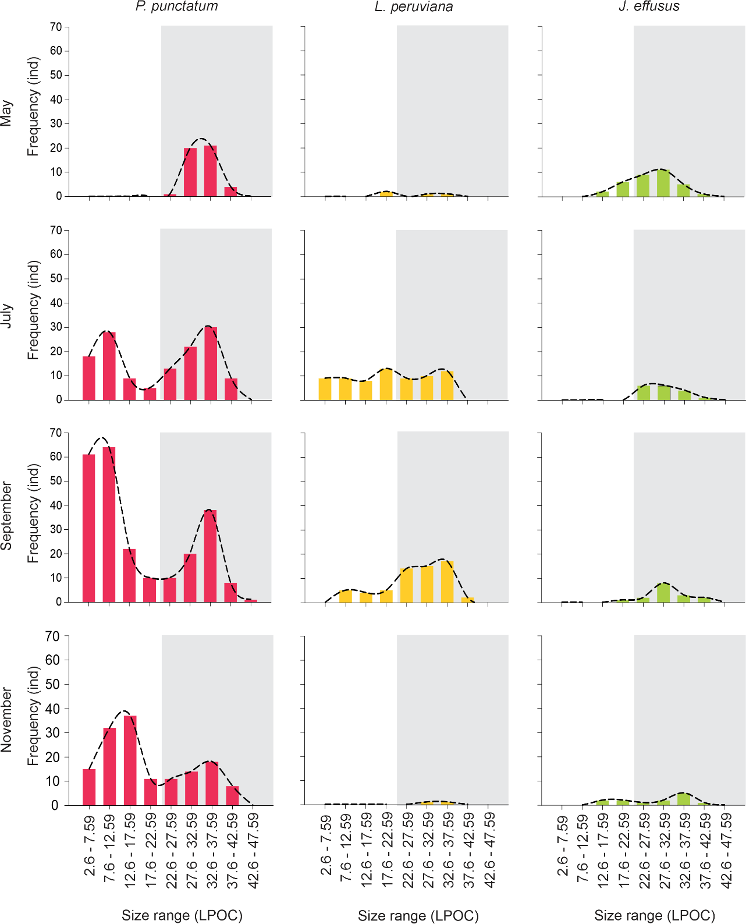
SMF 2. Size range of red swamp crayfish by macrophyte and per month, assessed in a tropical high mountain aquatic ecosystem. The areas of the charts in gray represent the sizes of adult individuals. Sizes in millimeters.
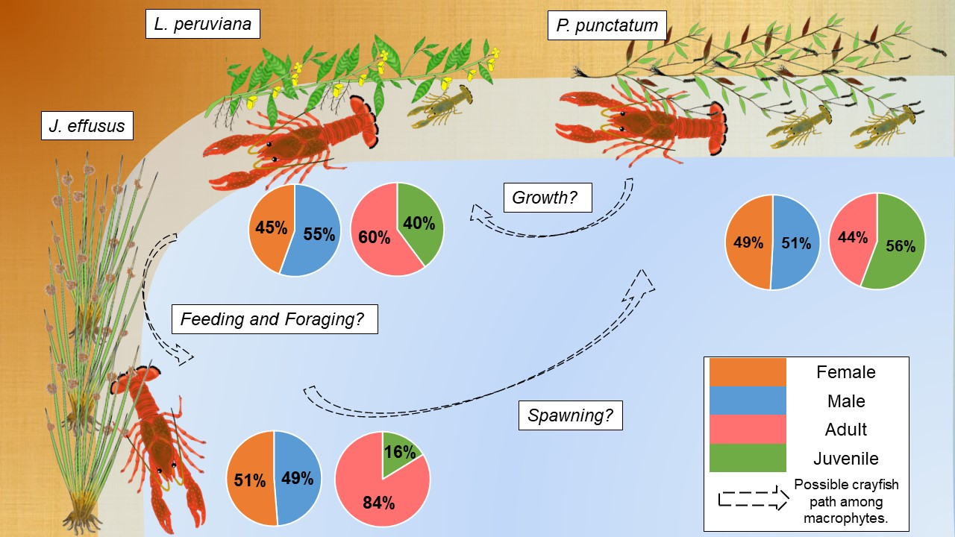
SMF 3. Habitat use by red crayfish in the macrophytes evaluated. J. effusus (Juncus effusus), L. peruviana (Ludwigia peruviana), P. punctatum (Polygonum punctatum).

