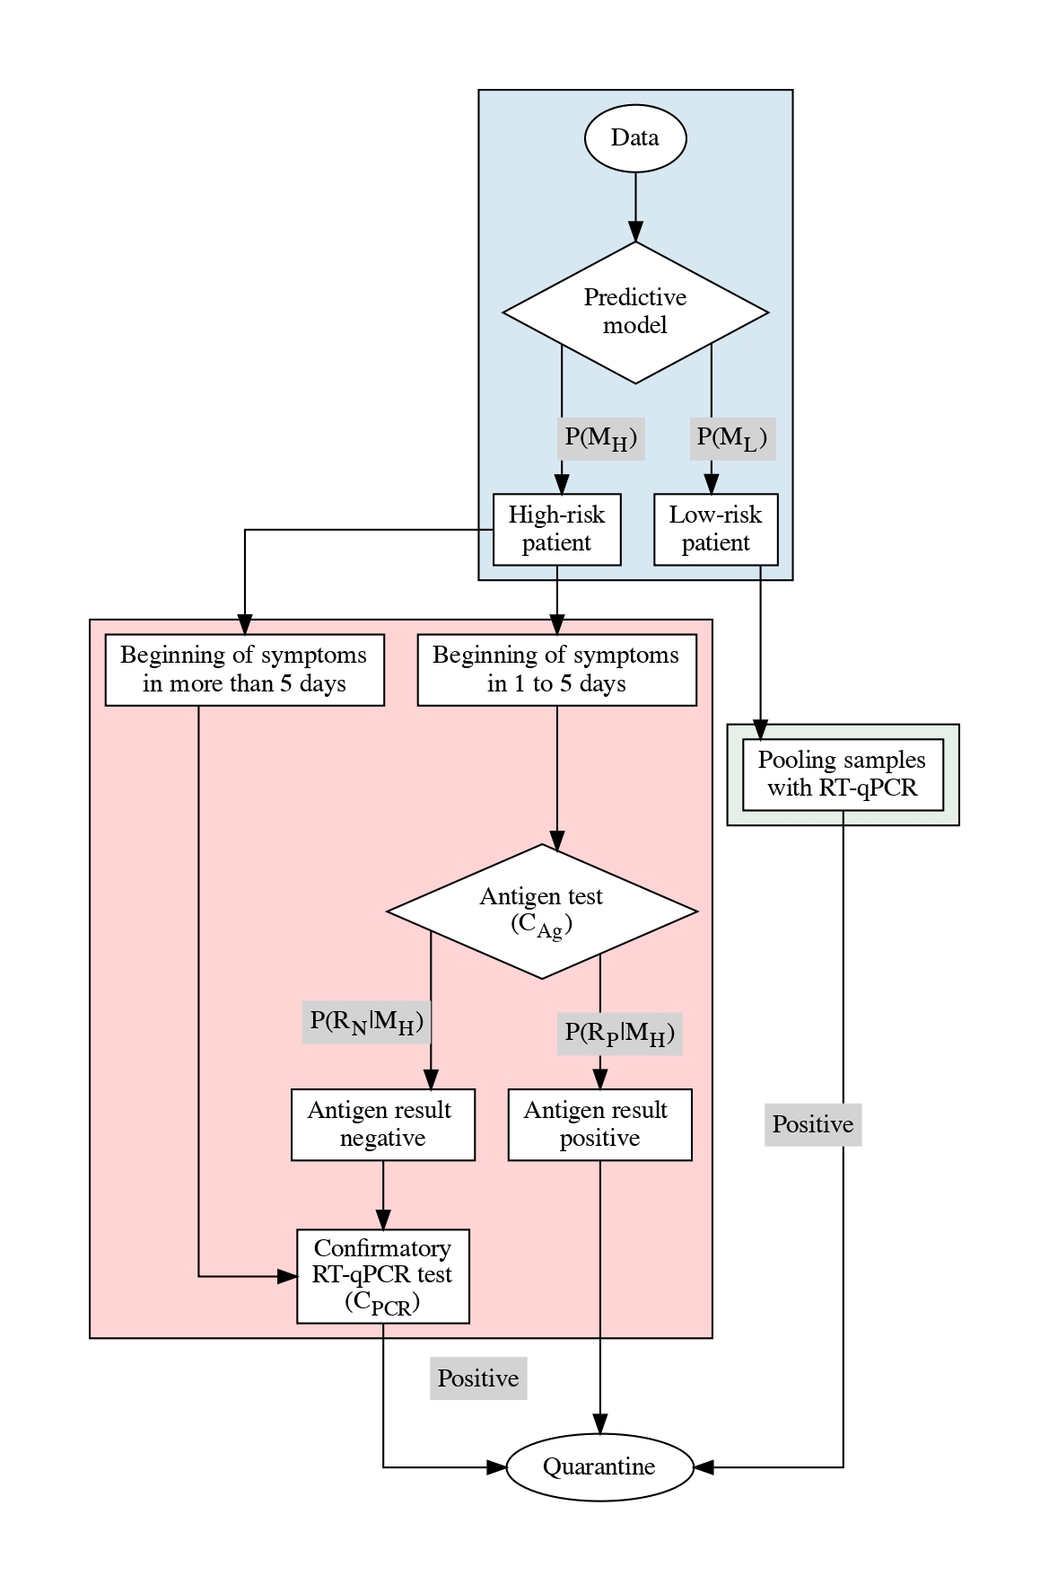

**SMF1.** Strategy 2. Strategy 1 is supplemented with pooling for low-risk patients.

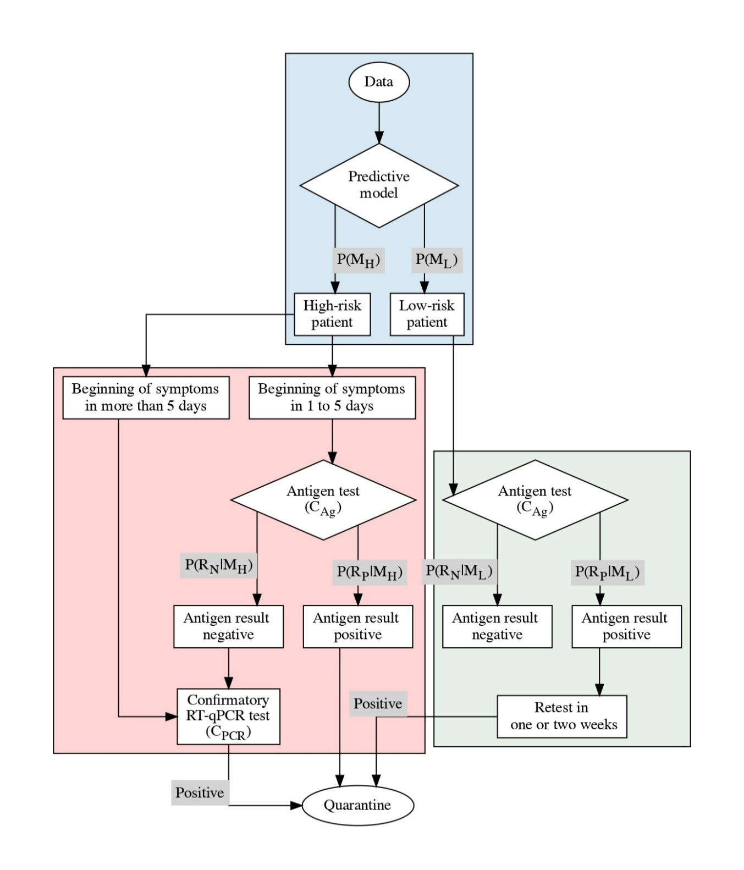

**SMF2.** Strategy 3. Instead of pooling as in Strategy 2, all low-risk patients undergo antigen-based testing, and positive cases are required to have a similar, confirmatory test within one or two weeks.

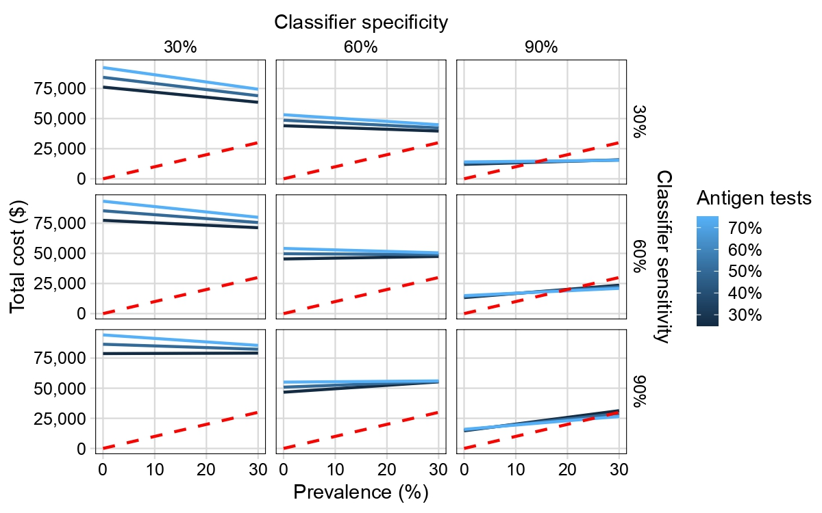

**SMG1.** Total cost structure for Strategy 1. Using RT-qPCR tests only for the high-risk group predicted by the pre-classifier on symptomatic patients matches minimizes cost while maximizing discovery of true positives at high specificity and sensitivity values, but only for a limited portion of the population.

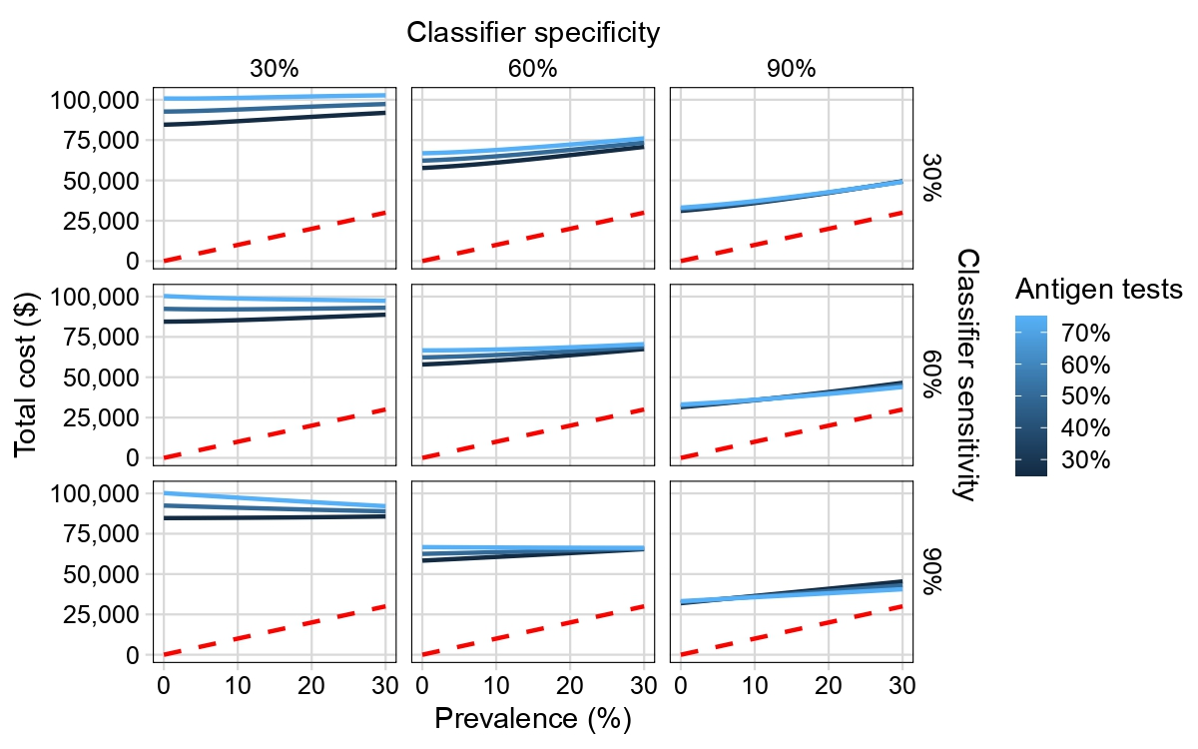

**SMG2.** Total cost structure for Strategy 2. Pool size equals 5 samples. Cost outcomes are similar to Strategy 1 at very low preva-lence, while a larger population receives testing thanks to the application of a pooling technique. Cost structure increases with prevalence, while specificity makes the effect of different antigen-based testing proportions less noticeable.

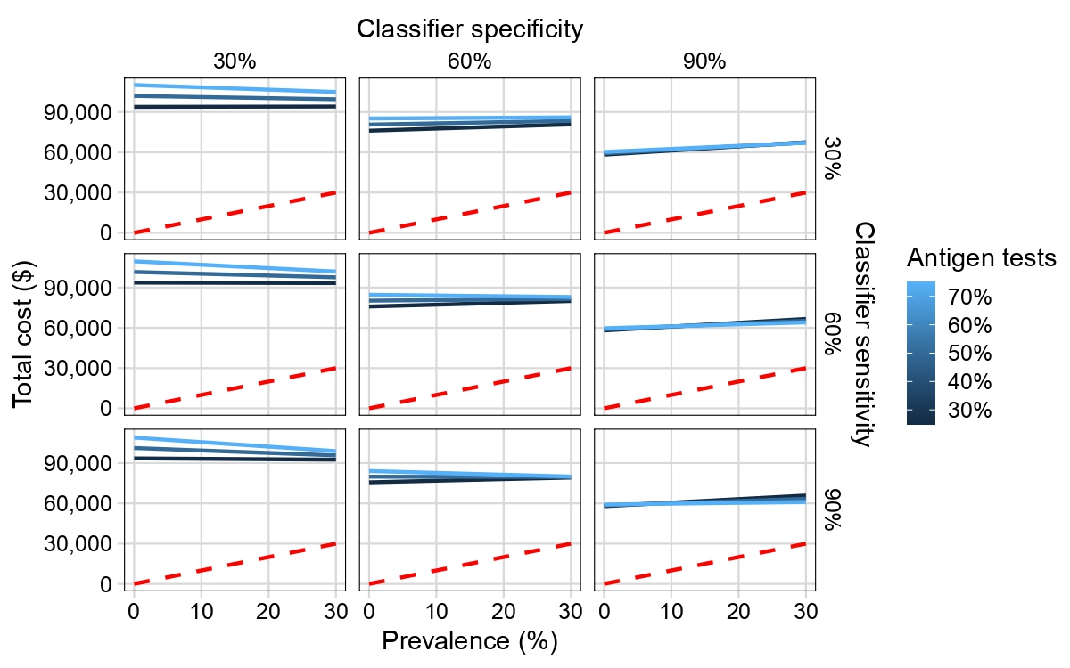

**SMG3.** Total cost according to Strategy 3. Costs are larger than for Strategies 1 and 2 due to an increased number of antigen-based tests applied to the low-risk group. Cost structure becomes less markedly modulated by prevalence.

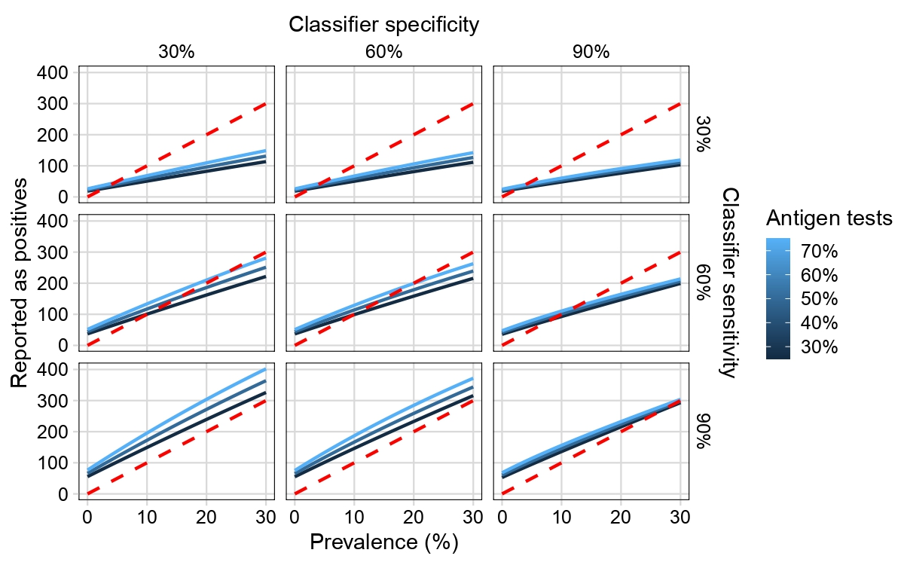

**SMG4.** Number of individuals reported as positive according Strategy 1. Model sensitivity critically modulates detection of true positive cases.

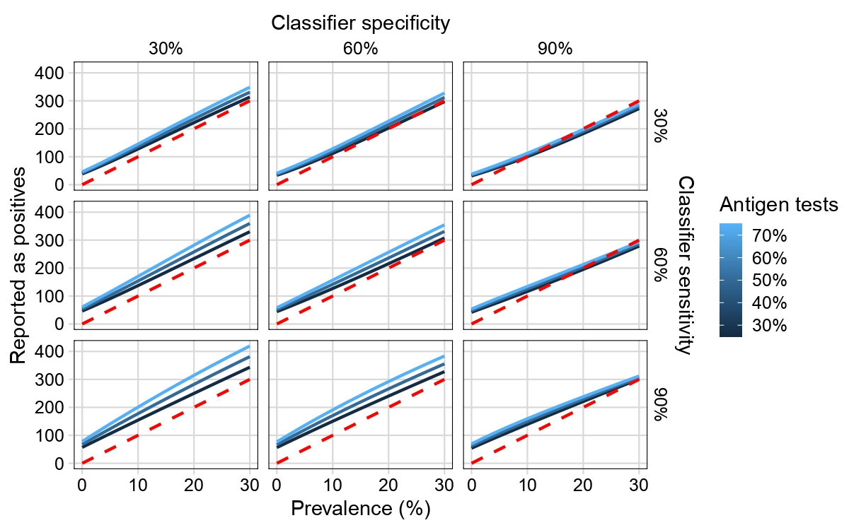

**SMG5.** Number of individuals reported as positive according Strategy 2. Pooling improves detection at low prevalence compared to Strategy 1, observed in the smaller number of crossings between true cases and reported cases.

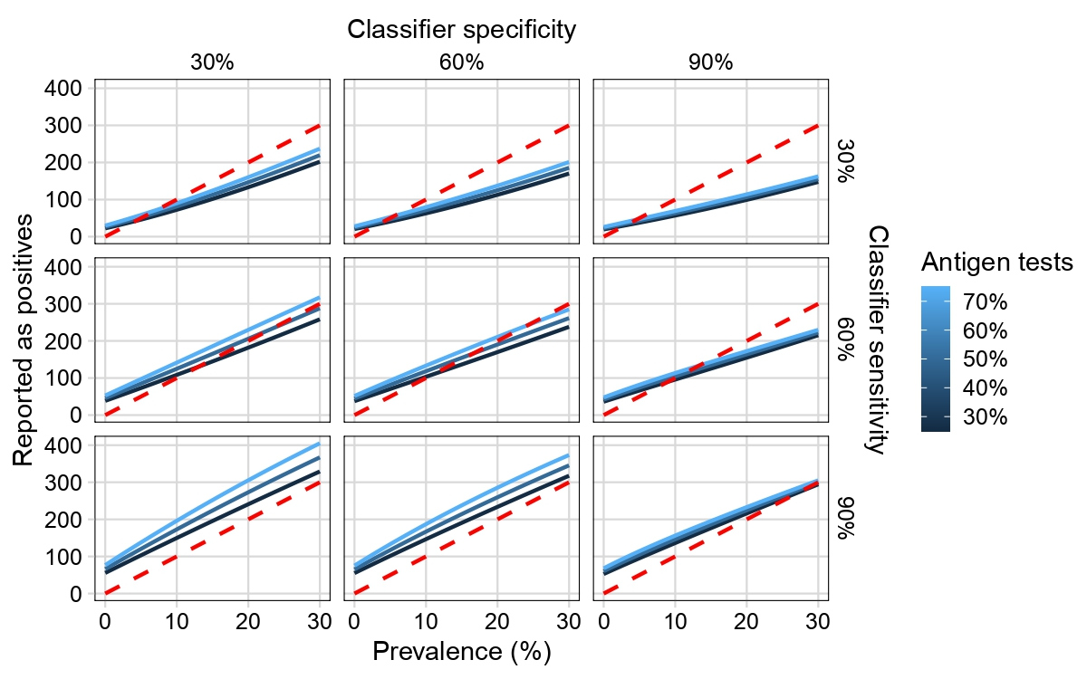

**SMG6.** Number of reported as positive according Strategy 3. Sensitivity is inversely correlated with the number of false negatives as prevalence increases, explained in part by the lower sensitivity of antigen-based tests and the increasing reliance on them.

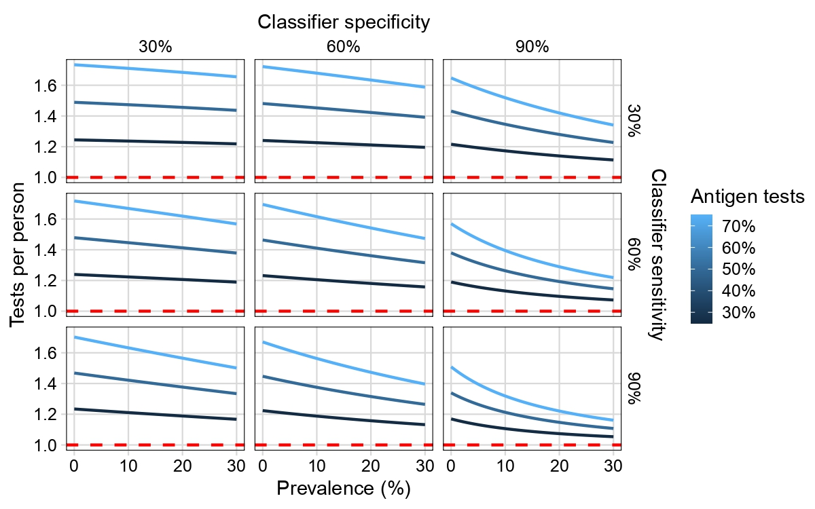

**SMG7.** Number of tests per person in Strategy 1. Low prevalence forces more frequent retesting with antigen-based technologies, while high prevalence approximates one test per person at high sensitivity and specificity.

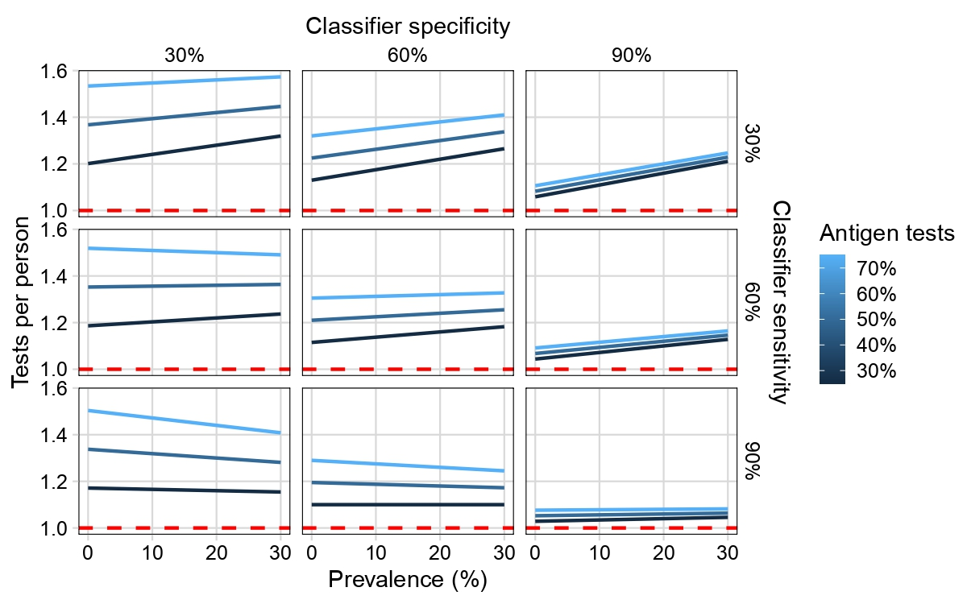

**SMG8.** Test per person in Strategy 3. Specificity strongly determines proximity to one test per person, but cannot reach a few tests as Strategy 2.

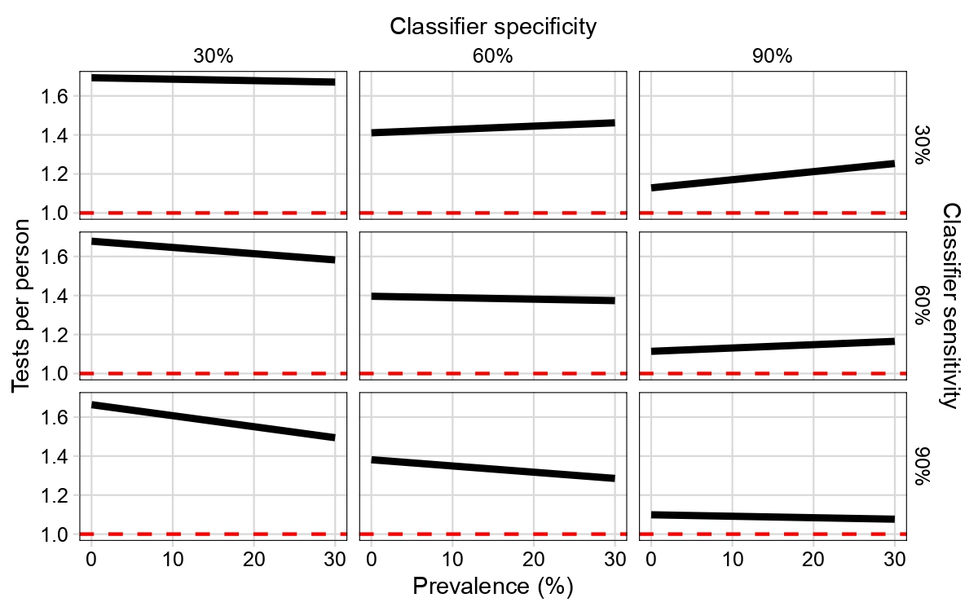

**SMG9.** Test per person in Strategy 4. Similar to Strategy 3, specificity determines proximity to one test per person. The constant number of tests at high specificity and sensitivity, despite changes in prevalence, points to their scalability.