MST 1

Riqueza de especies de macrolíquenes epífitos asociados a *Comarostaphylis arbutoides* y *Quercus* sp. en el Parque Nacional Volcán Barú, Chiriquí, Panamá

SMT 1

Species richness of epiphytic macrolichens associated with *Comarostaphylis arbutoides* and *Quercus* sp. in Baru Volcano National Park, Chiriqui, Panama

| **Zona / Especie** | **ZA** | **ZB** | **ZC** | ***Comarostaphylis arbutoides*** | ***Quercus* sp.** | |
| --- | --- | --- | --- | --- | --- | --- |
| **Cladoniaceae** |  |  |  |  | |  |
| *Cladonia chlorophaea* (Flörke ex Sommerf.) Spreng. | 0 | 1 | 0 | 3 | | 0 |
| *Cladonia squamosa* Hoffm. | 0 | 1 | 0 | 1 | | 0 |
| *Cladonia subradiata* (Vain.) Sandst. | 1 | 0 | 1 | 2 | | 0 |
| *Cladonia subsquamosa* Kremp. | 0 | 1 | 0 | 1 | | 0 |
| **Parmeliaceae** |  |  |  |  | |  |
| *Everniastrum cirrhatum* (Fr.) Hale | 1 | 1 | 1 | 18 | | 3 |
| *Everniastrum vexans* (Zahlbr. ex W.L. Culb. & C.F. Culb.) Hale ex Sipman | 1 | 0 | 0 | 1 | | 0 |
| *Hypotrachyna bogotensis* (Vain.) Hale | 1 | 1 | 1 | 17 | | 2 |
| *Hypotrachyna costaricensis* (Nyl.) Hale | 1 | 1 | 1 | 10 | | 5 |
| *Hypotrachyna imbricatula* (Zahlbr.) Hale | 1 | 1 | 1 | 11 | | 0 |
| *Hypotrachyna laevigata* (Sm.) Hale | 1 | 1 | 0 | 4 | | 1 |
| *Hypotrachyna microblasta* (Vain.) Hale | 1 | 0 | 1 | 2 | | 1 |
| *Hypotrachyna* aff. *reducens* (Nyl.) Hale | 1 | 1 | 0 | 4 | | 1 |
| *Parmotrema* sp. | 1 | 1 | 0 | 2 | | 2 |
| *Parmotrema dilatatum* (Vain.) Hale | 1 | 1 | 0 | 0 | | 1 |
| *Parmotrema praesorediosum* (Nyl.) Hale | 1 | 1 | 0 | 1 | | 4 |
| *Punctelia* sp. | 0 | 1 | 0 | 1 | | 1 |
| *Usnea* sp. 1 | 1 | 1 | 1 | 10 | | 1 |
| *Usnea* sp. 2 | 1 | 1 | 0 | 3 | | 1 |
| *Usnea* sp. 3 | 1 | 1 | 1 | 6 | | 0 |
| *Usnea* sp. 4 | 1 | 1 | 0 | 2 | | 3 |
| *Usnea* sp. 5 | 1 | 1 | 0 | 5 | | 3 |
| **Coccocarpiaceae** |  |  |  |  | |  |
| *Coccocarpia erythroxyli* (Spreng.) Swinscow & Krog | 1 | 0 | 0 | 1 | | 0 |
| *Coccocarpia filiformis* Arv. | 0 | 1 | 0 | 1 | | 0 |
| *Coccocarpia prostrata* Lücking, Aptroot & Sipman | 1 | 1 | 0 | 6 | | 1 |
| *Coccocarpia palmicola* (Spreng.) Arv. & D.J. Galloway | 1 | 1 | 0 | 14 | | 1 |
| **Collemataceae** |  |  |  |  | |  |
| *Leptogium azureum* (Sw.) Mont. | 1 | 0 | 1 | 0 | | 2 |
| *Leptogium burgessii* (L.) Mont. | 0 | 0 | 1 | 2 | | 0 |
| *Leptogium cyanescens* (Ach.) Körb. | 1 | 0 | 1 | 1 | | 2 |
| *Leptogium denticulatum* Tuck. | 0 | 0 | 1 | 0 | | 1 |
| *Leptogium isidiosellum* (Riddle) Sierk | 1 | 0 | 1 | 4 | | 2 |
| *Leptogium laceroides* B. de Lesd. | 0 | 1 | 1 | 4 | | 1 |
| **Lobariaceae** |  |  |  |  | |  |
| *Lobaria dissecta* (Sw.) Raeusch. | 1 | 0 | 1 | 4 | | 2 |
| *Lobaria erosa* (Eschw.) Trevis. | 0 | 1 | 1 | 6 | | 3 |
| *Lobariella crenulata* (Hook.) Yoshim. | 1 | 0 | 0 | 3 | | 0 |
| *Lobariella subexornata* (Zahlbr.) Yoshim. | 1 | 1 | 0 | 5 | | 1 |
| *Sticta* aff. *beauvoisii* Delise | 1 | 0 | 1 | 4 | | 1 |
| *Sticta cometia* Ach. | 1 | 0 | 0 | 1 | | 0 |
| *Sticta fuliginosa* (With.) Ach. | 1 | 0 | 0 | 2 | | 2 |
| *Sicta weigelii* (Ach.) Vain. | 1 | 1 | 1 | 3 | | 3 |
| **Pannariaceae** |  |  |  |  | |  |
| *Erioderma* sp. 1 | 1 | 0 | 0 | 1 | | 0 |
| *Erioderma* sp. 2 | 1 | 1 | 0 | 2 | | 0 |
| **Physciaceae** |  |  |  |  | |  |
| *Heterodermia japonica* (M. Satô) Swinscow & Krog | 1 | 1 | 1 | 2 | | 6 |
| *Heterodermia leucomelos* (L.) Poelt | 1 | 1 | 1 | 9 | | 2 |
| *Heterodermia microphylla* (Kurok.) Skorepa | 1 | 0 | 0 | 0 | | 1 |
| *Heterodermia* aff. *pseudospeciosa* (Kurok.) W.L. Culb. | 1 | 0 | 0 | 0 | | 1 |
| *Heterodermia* sp. 1 | 1 | 0 | 0 | 2 | | 1 |
| *Heterodermia* sp. 2 | 0 | 1 | 0 | 0 | | 2 |

Nota: datos por zona indican presencia (1) y ausencia (0) de la especie indicada. Los datos de forófito indican la cantidad de forófitos en los que se presentó la especie indicada.

Note: Data by zone indicate presence (1) and absence (0) of the specified species. Phorophyte data indicate the number of phorophytes in which the specified species was found.

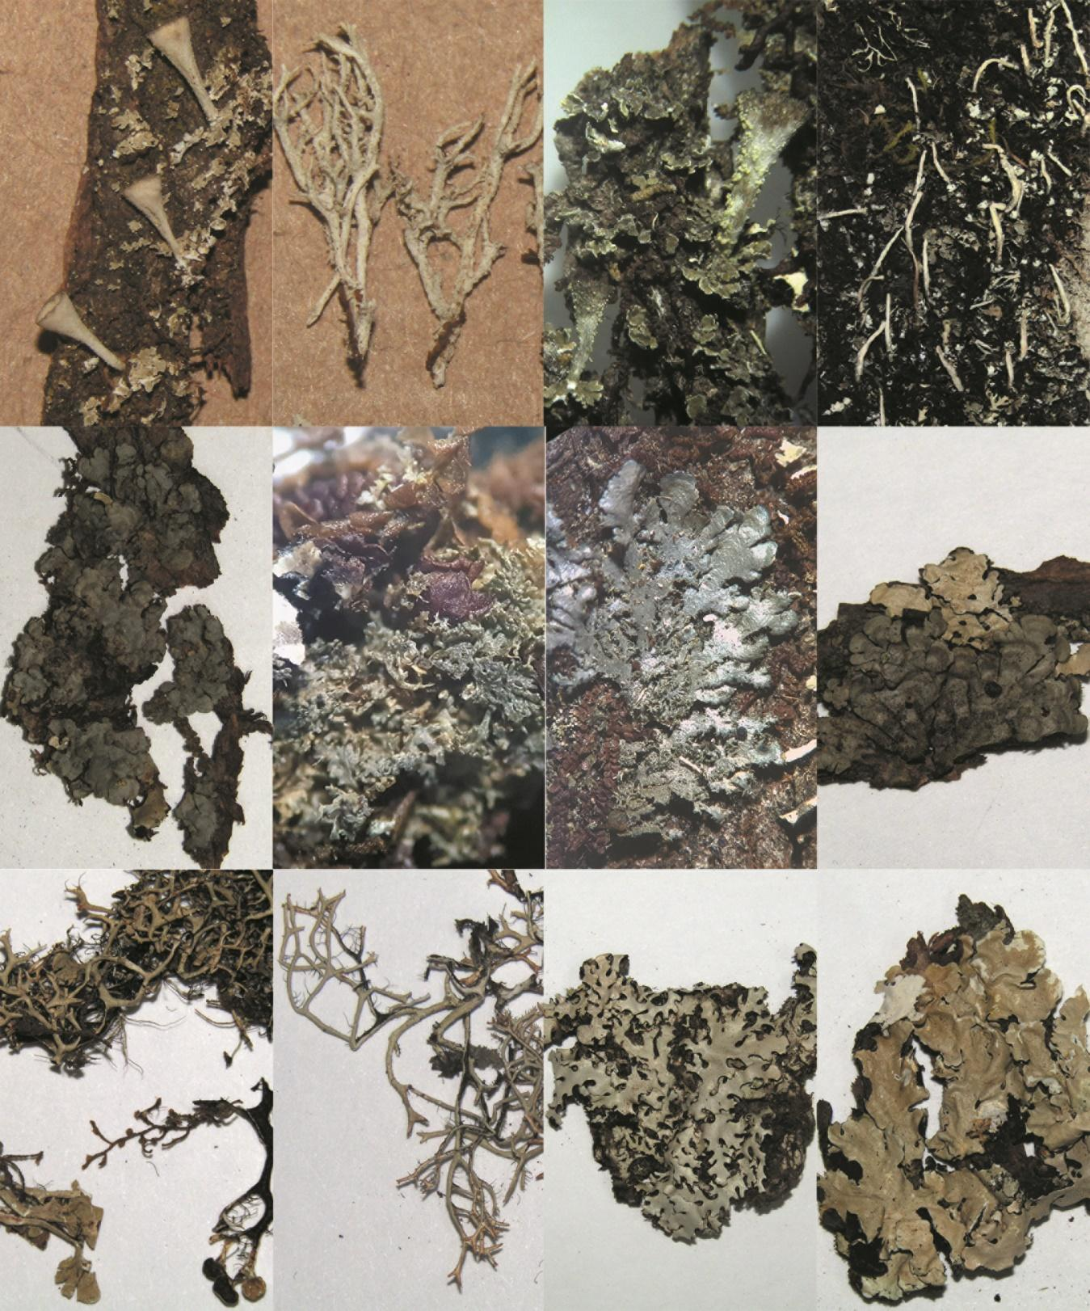

1

5

6

4

3

2

7

8

12

11

10.

9

**MSF 1.** Especies de macrolíquenes epífitos encontrados en el Parque Nacional Volcán Barú, Panamá**. 1.** *Cladonia chlorophaeae***, 2.** *Cladonia squamosa*, **3.** *Cladonia subsquamosa*, **4.** *Cladonia subradiata,* **5.** *Coccocarpia erythroxyli,* **6.** *Coccocarpia filiformis,* **7.** *Coccocarpia microphylla,* **8***. Coccocarpia palmicola,* **9.** *Everniastrum cirrhatum,* **10.** *Everniastrum vexans,* **11.** *Hypotrachyna bogotensis,* **12.** *Hypotrachyna costaricensis*

**SMF 1.** Epiphytic macrolichen species found in Baru Volcano National Park, Panama.**1.** *Cladonia chlorophaeae***, 2.** *Cladonia squamosa*, **3.** *Cladonia subsquamosa*, **4.** *Cladonia subradiata,* **5.** *Coccocarpia erythroxyli,* **6.** *Coccocarpia filiformis,* **7.** *Coccocarpia microphylla,* **8***. Coccocarpia palmicola,* **9.** *Everniastrum cirrhatum,* **10.** *Everniastrum vexans,* **11.** *Hypotrachyna bogotensis,* **12.** *Hypotrachyna costaricensis*

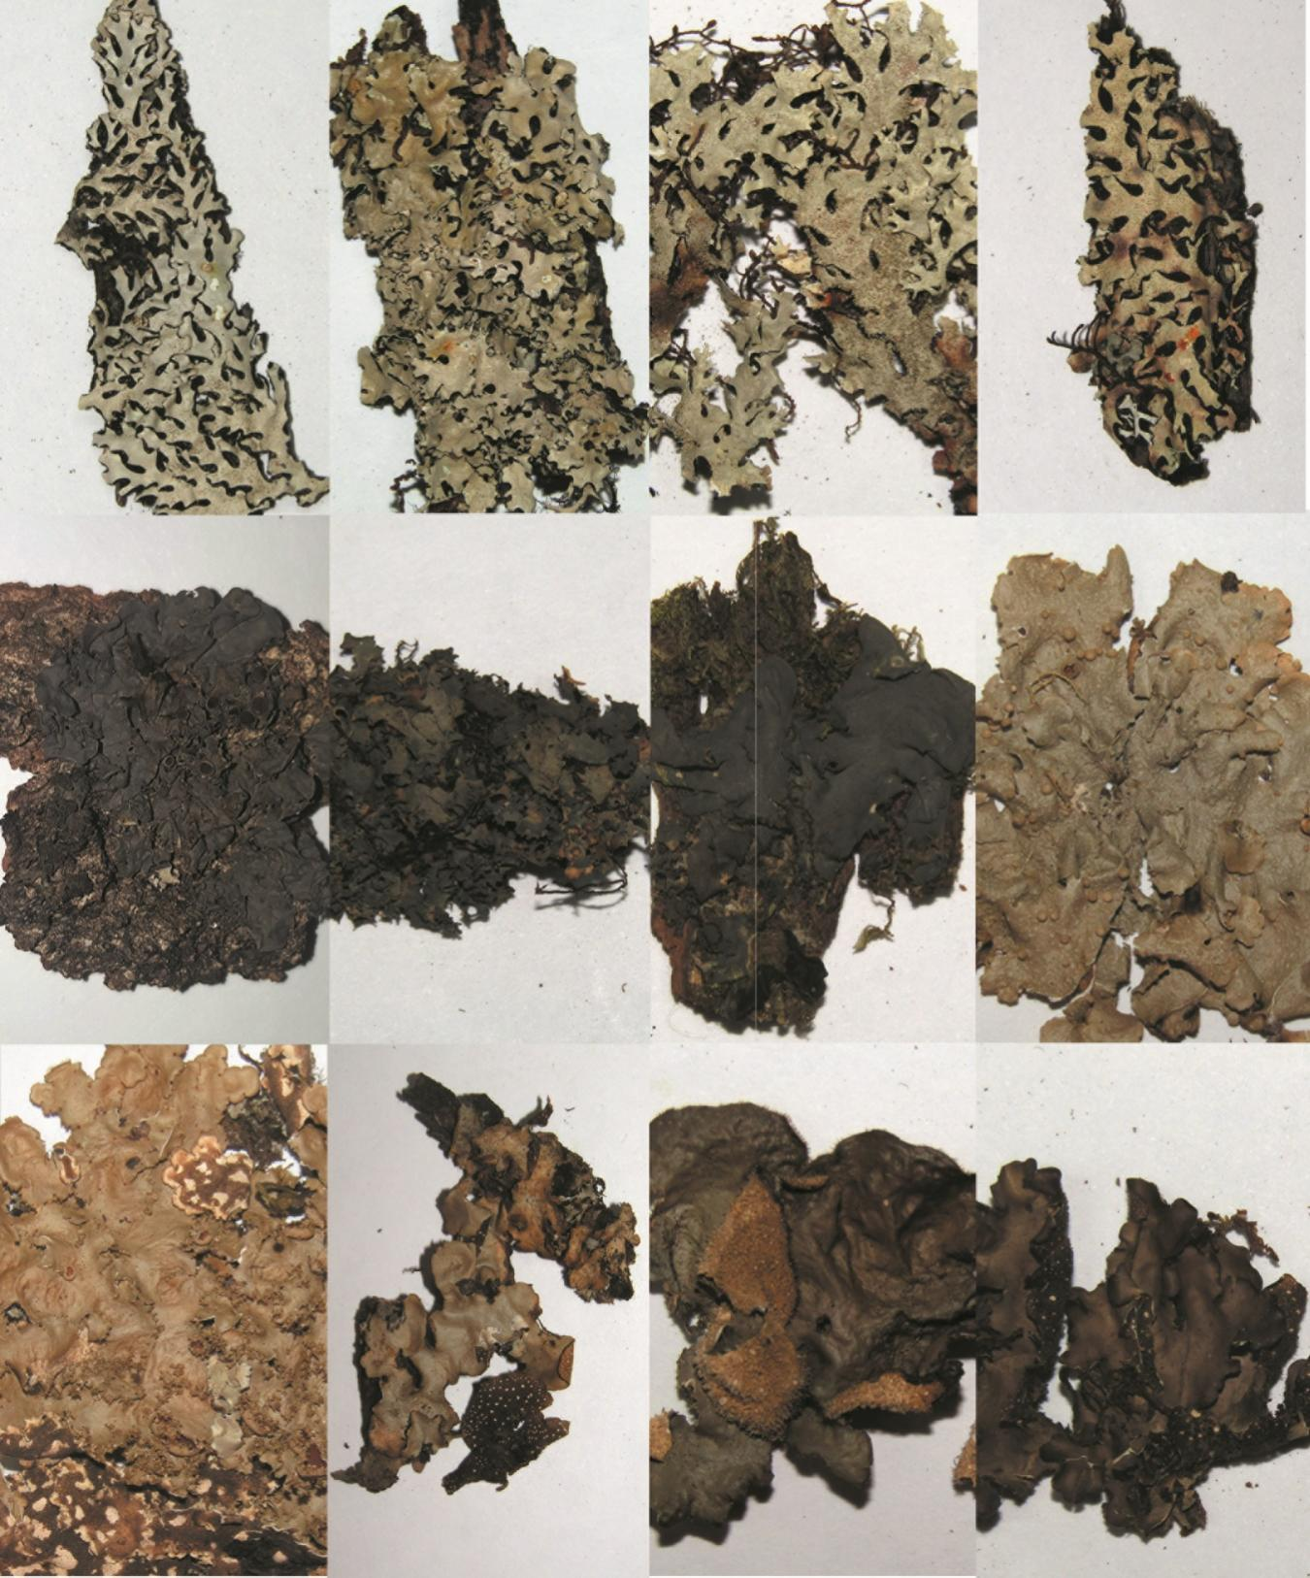

13

14

15

16

17

18

19

20

21

22

23

24

**MSF 2.**Especies de macrolíquenes epífitos encontrados en el Parque Nacional Volcán Barú, Panamá**. 13.** *Hypotrachyna imbricatula***, 14.** *Hypotrachyna laevigata*, **15.** *Hypotrachyna microblasta*, **16.** *Hypotrachyna reducens,* **17.** *Leptogium azureum,* **18.** *Leptogium burgesii,* **19.** *Leptogium cyanescens,* **20***. Lobariella crenulata,* **21.** *Lobaria dissecta,* **22.** *Sticta aff. beauvoisii,* **23.** *Sticta fuliginosa,* **24.** *Sticta weigelii*

**SMF 2.** Epiphytic macrolichen species found in Baru Volcano National Park, Panama.**13.** *Hypotrachyna imbricatula***, 14.** *Hypotrachyna laevigata*, **15.** *Hypotrachyna microblasta*, **16.** *Hypotrachyna reducens,* **17.** *Leptogium azureum,* **18.** *Leptogium burgesii,* **19.** *Leptogium cyanescens,* **20***. Lobariella crenulata,* **21.** *Lobaria dissecta,* **22.** *Sticta aff. beauvoisii,* **23.** *Sticta fuliginosa,* **24.** *Sticta weigelii.*