Supplementary Material
ANOVA – First set of experiments – Ventura & Oliveira
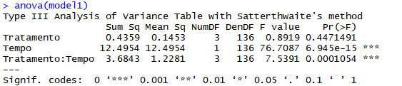
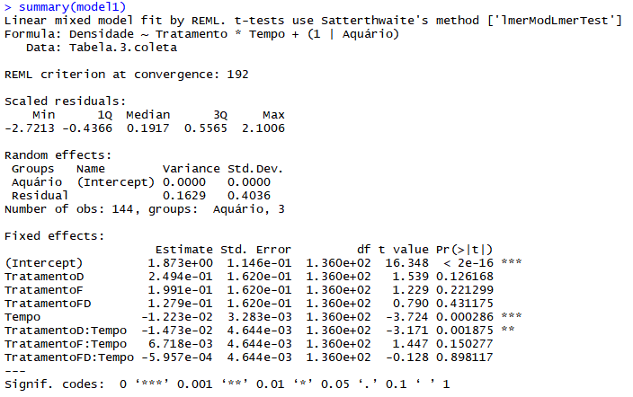
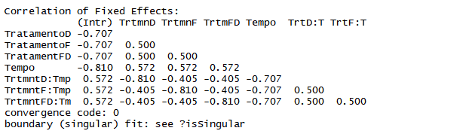

ANOVA – Second set of experiments – Ventura & Oliveira
