**DIGITAL APPENDIX 1**

**ns**



**r = 0.89**\*

**r = 0.65**\*

**r = 0.70**\*

**ns**

**ns**

*AGB*

*DBH*

*TH*

*WBD*

Correlation matrix between dependent and independent variables used for model adjustment from 37 recent dead fallen trees in the Atlantic Forest, Dois Irmãos State Park, Northeast Brazil; ns= non significant; * = significant. AGB: aboveground biomass (kg.tree-1); *DBH*: diameter at breast height (cm); *TH*: total tree height (m); *WBD*: wood basic density (g.cm-3). In the lower diagonal, darker colours represent higher correlation.

**DIGITAL APPENDIX 2**

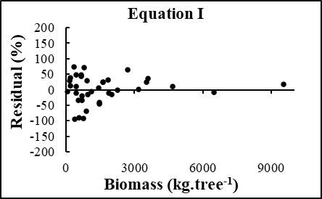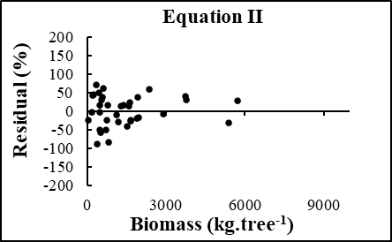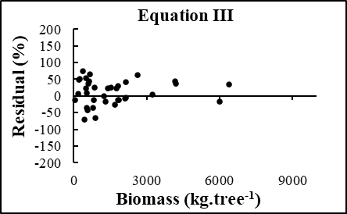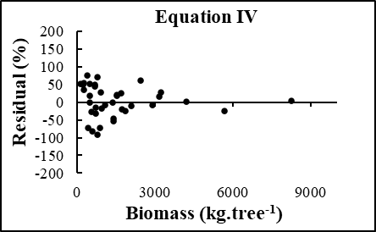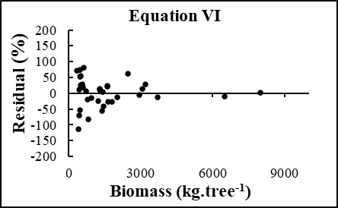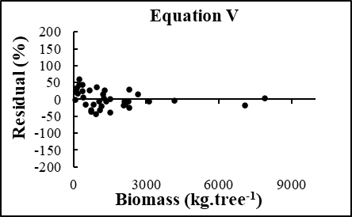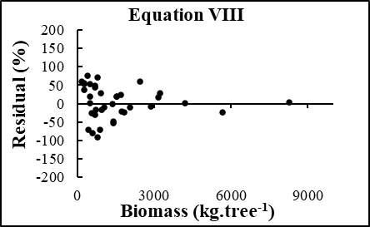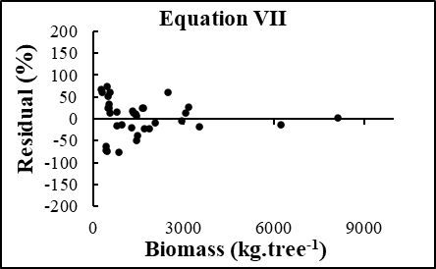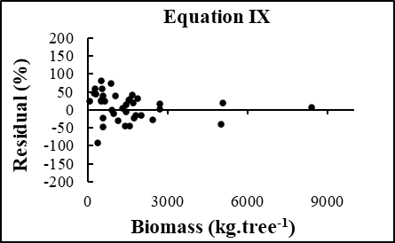

Graphic distribution of residuals (%) for equations generated for estimative of above ground biomass from dead fallen trees in the Atlantic Forest, Dois Irmãos State Park, Northeast Brazil.

**DIGITAL APPENDIX 3**

Estimatives of AGB (above ground biomass) for 37 trees ranked by the diameter at breast height (DBH), in the Atlantic Forest, Dois Irmãos State Park, Northeast Brazil, using five available equations (EQ. I to V) and alocal equation.

**DIGITAL APPENDIX 4**

Data from the 37 recently dead fallen trees (DFT) sampled in the RAPELD plots along the PPBio module, in the Dois Irmãos State Park (PEDI), Pernambuco, Brazil

|  |  |  |  |  |  |
| --- | --- | --- | --- | --- | --- |
| **Individuals number** | **DBH**  **(cm)** | **Heights**  **(m)** | **WBD**  **(g.cm-3)** | **Bole volume**  **(m3/tree)** | **AGB**  **(kg.tree-1)** |
| 1 | 49.66 | 18.30 | 0.42800 | 2.25 | 961.99 |
| 2 | 38.99 | 12.50 | 0.71029 | 1.74 | 1 235.90 |
| 3 | 25.11 | 12.88 | 0.44434 | 0.85 | 377.69 |
| 4 | 41.54 | 17.54 | 0.71364 | 2.93 | 2 090.97 |
| 5 | 13.85 | 10.44 | 0.85943 | 0.20 | 171.89 |
| 6 | 25.15 | 13.60 | 0.48675 | 0.72 | 350.46 |
| 7 | 37.08 | 21.80 | 0.50811 | 4.04 | 2 052.76 |
| 8 | 45.58 | 16.90 | 0.49681 | 4.56 | 2 265.45 |
| 9 | 12.7 | 16.60 | 0.56851 | 0.21 | 119.39 |
| 10 | 25.62 | 11.90 | 0.52368 | 1.57 | 822.18 |
| 11 | 23.01 | 20.80 | 0.80799 | 1.32 | 1 066.55 |
| 12 | 92.31 | 29.45 | 0.76823 | 10.28 | 7 897.40 |
| 13 | 29.28 | 14.40 | 0.80117 | 0.81 | 648.95 |
| 14 | 29.92 | 24.60 | 0.79681 | 1.37 | 1 091.63 |
| 15 | 20.47 | 15.95 | 0.53500 | 0.73 | 390.55 |
| 16 | 22.44 | 13.85 | 0.60945 | 1.17 | 713.06 |
| 17 | 27.06 | 17.90 | 0.86027 | 1.74 | 1 496.87 |
| 18 | 28.97 | 23.85 | 0.77287 | 1.96 | 1 514.83 |
| 19 | 76.39 | 20.55 | 0.76982 | 9.18 | 7 066.95 |
| 20 | 20.53 | 16.60 | 0.70361 | 0.69 | 485.49 |
| 21 | 13.85 | 14.90 | 0.39782 | 0.31 | 123.32 |
| 22 | 41.06 | 17.42 | 0.76531 | 1.66 | 1 270.41 |
| 23 | 37.08 | 19.81 | 0.75581 | 2.83 | 2 138.94 |
| 24 | 7.67 | 8.60 | 0.53448 | 0.12 | 64.14 |
| 25 | 18.94 | 15.28 | 0.43176 | 1.70 | 733.99 |
| 26 | 20.69 | 15.45 | 0.59936 | 0.39 | 233.75 |
| 27 | 56.72 | 24.56 | 0.48276 | 5.49 | 2 650.35 |
| 28 | 18.14 | 13.56 | 0.78831 | 0.12 | 94.60 |
| 29 | 54.11 | 19.79 | 0.57203 | 5.43 | 3 106.12 |
| 30 | 36.61 | 21.58 | 0.68185 | 2.00 | 1 363.70 |
| 31 | 27.28 | 12.20 | 0.81821 | 0.28 | 229.10 |
| 32 | 42.97 | 19.75 | 0.68252 | 3.36 | 2 293.27 |
| 33 | 25.46 | 17.85 | 0.69809 | 1.32 | 921.48 |
| 34 | 57.3 | 23.74 | 0.49268 | 4.64 | 2 286.04 |
| 35 | 32.05 | 23.65 | 0.71313 | 1.62 | 1 155.27 |
| 36 | 65.57 | 29.20 | 0.71688 | 5.80 | 4 157.90 |
| 37 | 38.93 | 23.72 | 0.43577 | 2.81 | 1 224.51 |