Apéndice digital 1
Curvas de cobertura del muestreo con respecto al número de muestras tomadas por río (A) y por mesohábitat (B)
Digital Appendix 1
Sampling coverage curves in function to the number of samples taken per stream (A) and meso-habitat (B)
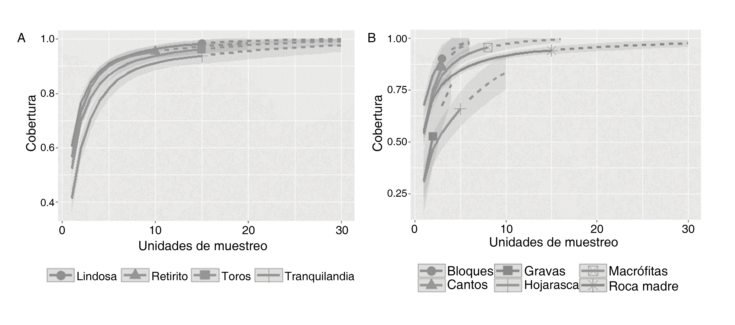

Apéndice digital 2
Géneros de macroinvertebrados reportados en los arroyos estudiados en enero de 2017 y 2018. Para cada uno se indica su hábito alimenticio (L: larva; A: adulto)
Digital Appendix 2
Macroinvertebrates genera reported in the streams studied in January 2017 and 2018. For each one, their functional feeding groups are indicated (L: larvae; A: adult)

Orden | Familia | Género | Hábito alimenticio | Bibliografía
Coleoptera | Elmidae | Austrolimnius | Recolector | Gallegos Sánchez, 2013
 |  | Heterelmis | Variable (L: recolector, triturador; A: recolector) | Chará-Serna, Chará, Zúñiga, Pearson, & Boyero, 2012; Chaves-Ulloa, Umaña-Villalobos, & Springer, 2014; Mendes, Kiffer, & Moretti, 2017; Tomanova et al., 2006.
 |  | Luchoelmis | Sin información
 |  | Macrelmis | A: Recolector | Chará-Serna, Chará, Zúñiga, Pedraza, & Giraldo, 2010; Gallegos Sánchez, 2013
 |  | Microcylloepus | Variable (L: Recolector, raspador) | Chaves-Ulloa et al., 2014; Gallegos Sánchez, 2013; Saulino, Corbi, & Trivinho-Strixino, 2014; Tomanova et al., 2006
 |  | Neocylloepus | Sin información
 |  | Neoelmis | Variable (L: Recolector; A: Raspador) | Chaves-Ulloa et al., 2014; Gallegos Sánchez, 2013; Mendes et al., 2017; Tomanova et al., 2006
 |  | Xenelmis | Variable (L: Recolector; A: Raspador) | Mendes et al., 2017
 | Hydroscaphidae | Scaphydra cf. | Raspador | Merritt et al., 2008
 |  | Hydroscapha | Raspador | Merritt et al., 2008
 | Lampyridae | Sin determinar | Depredador | Domínguez & Fernández, 2009
 | Psephenidae | Psephenus | Raspador | Merritt et al., 2008
Decapoda | Paleomonidae | Macrobrachium | Depredador | Collins & Paggi, 1997
Diptera | Ceratopogonidae | Bezzia | Depredador | Merritt et al., 2008; Santos, 2014; Spinelli & Wirth, 1991
 | Chironomidae | Ablabesmyia | Depredador | Cummins, 1973; Henriques-Oliveira et al., 2003; Merritt et al., 2008
 |  | Chironomus | Recolector | Santos, 2014
 |  | Beardius | Recolector | da Silva Laurindo, Calcidoni Moreira, Lucas Bochini, & Silveira Ruiz, 2008
 |  | Corynoneura | Recolector | Henriques-Oliveira et al., 2003; Saulino et al., 2014
 |  | Cricotopus | Variable (Fragmentador, Recolector) | Chará-Serna et al., 2012; Saulino et al., 2014
 |  | Endotribelos | Fragmentador | Chará-Serna et al., 2012
 |  | Fissimentum | Recolector | Da Silva Laurindo et al., 2008
 |  | Labrundinia | Depredador | Santos, 2014; Saulino et al., 2014
 |  | Lauterborniella | Recolector | Heino, 2008
 |  | Lopescladius | Recolector | Henriques-Oliveira et al., 2003; Saulino et al., 2014
 |  | Macropelopia | Depredador | Cummins, 1973; Merritt et al., 2008
 |  | Nilotanypus | Depredador | Cummins, 1973; Merritt et al., 2008; Santos, 2014
 |  | Onconeura | Recolector | Saulino et al., 2014
 |  | Parametriocnemus | Recolector | Chará-Serna et al., 2012; Saulino et al., 2014
 |  | Pentaneura | Depredador | Saulino et al., 2014
 |  | Phaenopsectra | Raspador | Mihuc & Toetz, 1994
 |  | Polypedilum | Variable (Recolector, Fragmentador, Depredador) | Chará-Serna et al., 2012; Heino, 2008; Merritt et al., 2008; Saulino et al., 2014
 |  | Rheotanytarsus | Recolector | Chará-Serna et al., 2012; Saulino et al., 2014
 |  | Riethia | Recolector | Saulino et al., 2014
 |  | Stenochironomus | Fragmentador | Chará-Serna et al., 2012; Santos, 2014
 |  | Tanytarsus | Variable (Filtrador, Recolector) | Heino, 2008; Santos, 2014; Saulino et al., 2014
 |  | Thienemannimyia | Depredador | Saulino et al., 2014
 |  | Xestochironomus | Recolector | Santos 2014
 | Culicidae | Anopheles | Filtrador | Merritt, Dadd, & Walker, 1992
 | Corethrellidae | Sin determinar | Depredador | Merritt et al., 2008
 | Dixidae | Sin determinar | Recolector | Merritt et al., 2008
 | Empididae | Hemerodromia | Variable (Depredador, Fragmentador) | Chará-Serna et al., 2010; Merritt et al., 2008
 | Muscidae | Limnophora | Depredador | Gallegos Sánchez, 2013
 | Simuliidae | Simulium | Recolector | Chará-Serna et al., 2012; Cummins, 1973
 | Tipulidae | Hexatoma | Depredador | Chará-Serna et al., 2012; Merritt et al., 2008; Tomanova et al., 2006
Ephemeroptera | Baetidae | Americabaetis | Variable (Raspador, Recolector) | Chará-Serna et al., 2012; Fogaça, Gomes, & Higuti, 2013
 |  | Cloeodes | Recolector | Fogaça et al., 2013
 | Caenidae | Caenis | Variable (Recolector, Raspador) | Chaves-Ulloa et al., 2014; Fogaça et al., 2013; Ramírez & Gutiérrez-Fonseca, 2014; Saulino et al., 2014
 | Coryphoridae | Coryphorus | Sin información | Ramírez & Gutiérrez-Fonseca, 2014
 | Euthyplociidae | Campylocia | Recolector | Merritt et al., 2008
 | Leptohyphidae | Haplohyphes | Recolector | Chará-Serna et al., 2010
 |  | Leptohyphodes | Recolector | Chará-Serna et al., 2012
 |  | Tricorythopsis | Raspador | Baptista et al., 2006
 | Leptophlebiidae | Farrodes | Variable (Recolector, Filtrador) | Chará-Serna et al., 2012; Fogaça et al., 2013; Santos, 2014
 |  | Miroculis | Variable (Raspador, Recolector) | Ceneviva-Bastos, Prates, de Mei Romero, Bispo, & Casatti, 2017; Mendes et al., 2017; Santos, 2014; Saulino et al., 2014
 |  | Ulmeritoides cf. | Variable (Raspador, Fragmentador) | Mendes et al., 2017; Santos, 2014
Hemiptera | Corixidae | Tenagobia | Raspador | Saulino et al., 2014
 | Gelastocoridae | Gelastocoris | Depredador | Domínguez & Fernández, 2009
 | Naucoridae | Pelocoris | Depredador | Domínguez & Fernández, 2009
 | Nepidae | Telmatotrephes | Depredador | Domínguez & Fernández, 2009
 | Veliidae | Mesoveloidea | Depredador | Domínguez & Fernández, 2009
 |  | Microvelia | Depredador | Domínguez & Fernández, 2009; Santos, 2014
 |  | Rhagovelia | Variable (Depredador, Recolector) | Chará-Serna et al., 2010; Domínguez & Fernández, 2009
Lepidoptera | Crambidae | Parapoynx | Fragmentador | Santos, 2014; Saulino et al., 2014
 |  | Petrophila | Raspador | Chaves-Ulloa et al., 2014; Merritt et al., 2008; Tomanova et al., 2006
Megaloptera | Corydalidae | Corydalus | Depredador | Chará-Serna et al., 2010
Odonata | Calopterygidae | Heterina | Depredador | Chará-Serna et al., 2010; Santos, 2014
 | Coenagrionidae | Argia | Depredador | Chará-Serna et al., 2010; Saulino et al., 2014
 | Gomphidae | Erpetogomphus | Depredador | Merritt et al., 2008
 | Libellulidae | Tholymis | Depredador | Merritt et al., 2008
 | Megapodagrionidae | Megapodragrion | Depredador | Chará-Serna et al., 2010; Merritt et al., 2008;
 |  | Heteragrion | Depredador | Chará-Serna et al., 2010; Merritt et al., 2008;
Plecoptera | Perlidae | Anacroneuria | Depredador | Chará-Serna et al., 2012; Gallegos Sánchez, 2013; Mendes et al., 2017
Trichoptera | Calamoceratidae | Phylloicus | Fragmentador | Chará-Serna et al., 2012; Fogaça et al., 2013; Mendes et al., 2017
 | Glossosomatidae | Mortoniella | Variable (Fragmentador, Raspador) | Mendes et al., 2017; Saulino et al., 2014
 | Helicopsychidae | Helicopsyche | Raspador | Cummins, 2016; Merritt et al., 2008
 | Hydropsychidae | Blepharopus | Filtrador | Merritt et al., 2008
 |  | Smicridea | Variable (Filtrador, Fragmentador) | Chará-Serna et al., 2010; Mendes et al., 2017; Santos, 2014
 | Hydroptilidae | Hydroptila | Raspador | Fogaça et al., 2013; Saulino et al., 2014
 |  | Mayatrichia | Raspador | Sganga, 2011
 |  | Oxyethira | Variable (Raspador, Filtrador) | Fogaça et al., 2013
 | Leptoceridae | Triaenodes | Fragmentador | Barker, Hutchens, & Luken, 2014
 |  | Triplectides | Fragmentador | Chará-Serna et al., 2010; Mendes et al., 2017
 | Philopotamidae | Chimarra | Filtrador | Fogaça et al., 2013
 | Polycentropodidae | Polycentropus | Depredador | Chará-Serna et al., 2010; Merritt et al., 2008;
 |  | Polyplectropus | Depredador | Merritt et al., 2008; Santos, 2014
 | Xiphocentronidae | Xiphocentron | Recolector | Merritt et al., 2008

