APÉNDICE DIGITAL 1
- Ubicación regional del área de estudio en Colombia B. con detalle departamental C. y local.
DIGITAL APPENDIX 1
- Regional location of the study area in Colombia B. with departmental detail C. and local.

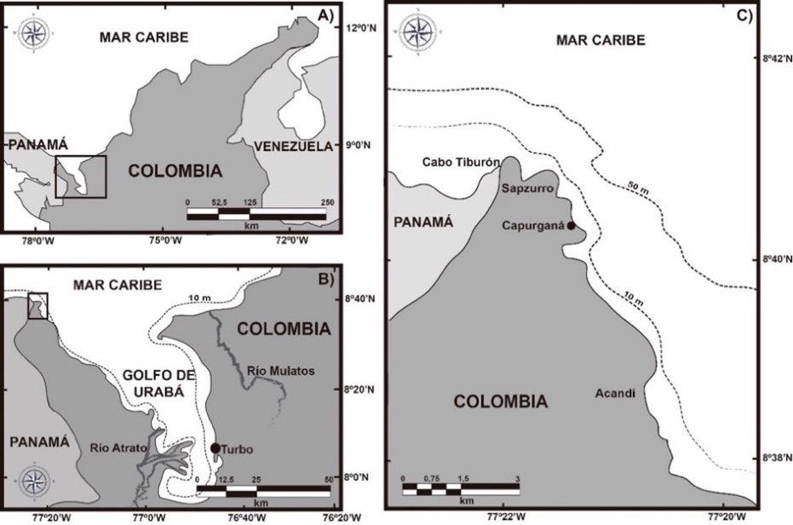

APÉNDICE DIGITAL 2
ANOVA para variación del crecimiento (cm²/día) de los individuos respecto a la competencia, la presencia o no de herbívoros y las épocas climáticas
DIGITAL APPENDIX 2
ANOVA for variation of the growth (cm²/day) of the individuals with respect to the competition, the presence or not of herbivores and the climatic seasons

Fuente | Gl | Suma de Cuadrados | Cuadrado Medio | Razón-F | Valor-P
Three Way Experimento Completo
A: Herbivoría | 1 | 1.29E⁻⁰⁵ | 1.293E⁻⁰⁵ | 7.8910 | 0.0066*
B: Época | 1 | 7.82E⁻⁰⁶ | 7.816E⁻⁰⁶ | 4.7707 | 0.0326*
C: Competencia | 7 | 1.82E⁻⁰⁵ | 2.598E⁻⁰⁶ | 1.5855 | 0.1558
Herbivoría*Época | 1 | 7.69E⁻⁰⁷ | 7.691E⁻⁰⁷ | 0.4694 | 0.4957
Herbivoría*Competencia | 7 | 7.36E⁻⁰⁶ | 1.051E⁻⁰⁶ | 0.6416 | 0.7198
Época*Competencia | 7 | 7.11E⁻⁰⁶ | 1.016E⁻⁰⁶ | 0.6200 | 0.7375
Herbivoría*Época*Competencia | 7 | 6.23E⁻⁰⁶ | 8.906E⁻⁰⁷ | 0.5436 | 0.7982
Two Way – Época Húmeda
Treatment | 7 | 9.28E⁻⁰⁶ | 1.33E⁻⁰⁶ | 0.7701 | 0.6163
Herbivory | 1 | 3.70E⁻⁰⁶ | 3.70E⁻⁰⁶ | 2.1457 | 0.1527
Treatment*Herbivory | 7 | 3.15E⁻⁰⁶ | 4.50E⁻⁰⁷ | 0.2612 | 0.9644
Treatment | 7 | 9.28E⁻⁰⁶ | 1.33E⁻⁰⁶ | 0.7701 | 0.6163
Two Way – Época Seca
Treatment | 7 | 1.60E⁻⁰⁵ | 2.29E⁻⁰⁶ | 1.4712 | 0.2127
Herbivory | 1 | 1.00E⁻⁰⁵ | 1.00E⁻⁰⁵ | 6.4341 | 0.0162
Treatment*Herbivory | 7 | 1.04E⁻⁰⁵ | 1.49E⁻⁰⁶ | 0.9596 | 0.4764
Treatment | 7 | 1.60E⁻⁰⁵ | 2.29E⁻⁰⁶ | 1.4712 | 0.2127

APÉNDICE DIGITAL 3
Resultados de la prueba DMS para la variación del área de los juveniles. Cada celda contiene el valor P para las diferencias entre los tratamientos de sus respectivas filas y columnas
DIGITAL APPENDIX 3
Results of the DMS test for the variation of the juvenile area. Each cell contains the P-value for the differences between the treatments of their respective rows and columns

 | Control | H | R | H + R | M | H + M | R + M | H+R+M
Control |  | 0.3482* | 0.8150 | 0.2250 | 0.1020 | 0.3455* | 0.2570* | 0.2025
H | 0.3482* |  | 0.2667* | 0.1232 | 0.2462* | 0.0027 | 0.0912 | 0.1457
R | 0.8150 | 0.2667* |  | 0.1435 | 0.0205 | 0.2640* | 0.1755 | 0.1210
H+R | 0.2250 | 0.1232 | 0.1435 |  | 0.1230 | 0.1205 | 0.0320 | 0.0225
M | 0.1020 | 0.2462* | 0.0205 | 0.1230 |  | 0.2435* | 0.1550 | 0.1005
H+M | 0.3455* | 0.0027 | 0.2640* | 0.1205 | 0.2435* |  | 0.0885 | 0.1430
R+M | 0.2570* | 0.0912 | 0.1755 | 0.0320 | 0.1550 | 0.9885 |  | 0.0545
H+R+M | 0.2025 | 0.1457 | 0.1210 | 0.0225 | 0.1005 | 0.1430 | 0.0545
H = Coral Herido, R = Remoción algal, M = Alga artificial, H+R = Remoción+Herida del coral, H+M = Herida del coral+Alga artificial, R+M = Remoción algal + Alga artificial, H+R+M = todos los tratamientos combinados, * = diferencia de medias es significativa en el nivel 0.
H = Coral damage - wounded, R = Algae removal, M = Artificial Algae, H+R = Coral damage + Algae removal, H+M = Coral damage + Artificial algae, R+M = Algal removal + Artificial algae, H+R+M = all treatments combined, * = mean difference is significant at level 0.

APÉNDICE DIGITAL 4
Listado de especies de algas arrecifales encontradas durante el estudio (antes y después experimento)
DIGITAL APPENDIX 4
List of species of reef algae found during the study (before and after experiment)

 |  | Experimento
 | Taxa | Control | Remoc. | C. Her. | A. Art
 | ALGAS FILAMENTOSAS DE TAPETE
1 | Aglaothamnion sp. Feldmann-Mazoyer |  | X | X
2 | Aglaothamnion cordatum (Børgesen) Feldmann-Mazoyer |  | X
3 | Antithamnion antillanum Børgesen |  | X | X | X
4 | Boodleopsis sp. A. Gepp & ES Gepp |  |  |  | X
5 | Bryopsis sp. J.V. Lamouroux | X | X
6 | Bryopsis hypnoides J. V. Lamouroux |  | X |  | X
7 | Bryopsis plumosa (Hudson) C. Agardh |  | X
8 | Bryopsis ramulosa Montagne |  | X
9 | Ceramium brevizonatum H. E. Petersen | X | X
10 | Ceramium cimbricum H. E. Petersen | X | X | X | X
11 | Ceramium cruciatum Collins & Hervey | X | X | X | X
12 | Ceramium flaccidum (Harvey ex Kützing) Ardissone |  |  | X
13 | Chaetomorpha sp. Kützing |  | X | X | X
14 | Chondria baileyana (Montagne) Harvey |  | X
15 | Chondria capillaris (Hudson) M. J. Wynne |  |  | X
16 | Chondria floridana (Collins) M. Howe |  |  | X | X
17 | Cladophora albida (Nees) Kutzing |  | X | X
18 | Cladophora laetevirens (Dillwyn) Kützing |  | X | X | X
19 | Cladophora vagabunda (Linnaeus) Hoek |  | X | X
20 | Cyanobacteria sp1. Stanier ex Cavalier-Smith | X | X | X | X
21 | Cyanobacteria sp2. Stanier ex Cavalier-Smith |  | X
22 | Cyanobacteria sp3. Stanier ex Cavalier-Smith |  |  | X
23 | Cyanobacteria sp4. Stanier ex Cavalier-Smith | X
24 | Cyanobacteria sp5. Stanier ex Cavalier-Smith |  | X
25 | Cyanobacteria sp6. Stanier ex Cavalier-Smith |  | X
26 | Cyanobacteria sp7. Stanier ex Cavalier-Smith |  |  | X
27 | Cyanobacteria sp8. Stanier ex Cavalier-Smith |  |  |  | X
28 | Dasya sp. C. Agardh |  | X | X
29 | Hincksia sp. J. E. Gray | X | X
30 | Hincksia michelliae (Harvey) P. C. Silva |  | X
31 | Hypnea valentiae (Turner) Montagne |  |  |  | X
32 | Lophosiphonia sp. Falkenberg |  |  | X
33 | Lyngbya sp. C. Agardh ex Gomont |  | X |  | X
34 | Lyngbya confervoides C. Agardh ex Gomont |  | X
35 | Neosiphonia sertularioides (Grateloup) K. W. Nam & P. J. Kang |  | X | X | X
36 | Melanothamnus gorgoniae (Harvey) Díaz-Tapia & Maggs |  | X | X
37 | Polysiphonia sp. Greville | X | X | X
38 | Polysiphonia atlantica Kapraun & J. N. Norris | X | X | X
39 | Polysiphonia denudata (Dillwyn) Greville ex Harvey |  | X | X | X
40 | Polysiphonia havanensis Montagne | X | X | X | X
41 | Trichogleopsis pedicellata J. Schwede | X | X
 | TOTAL: 41
 | Porcentaje: 54.66 % | 13.8 % | 42.1 % | 25.3 % | 18.6 %
 | ALGAS CARNOSAS
42 | Acanthophora sp. J. V. Lamouroux |  |  | X
43 | Acanthophora spicifera (M.Vahl) Børgesen | X | X |  | X
44 | Apoglossum sp. J. Agardh |  | X
45 | Champia sp. Desvaux |  |  | X | X
46 | Champia salicornioides Harvey |  | X | X | X
47 | Dictyopteris delicatula J. V. Lamouroux | X | X |  | X
48 | Dictyopteris jamaicensis W. R Taylor |  |  | X
49 | Dictyota bartayresiana J. V. Lamouroux | X | X | X
50 | Dictyota caribaea Hörnig & Schnetter | X | X
51 | Dictyota humifusa Hörnig, Schnetter & Coppejans | X | X | X | X
52 | Dictyota menstrualis (Hoyt) Schnetter, Hörning & Weber-Peukert |  | X | X | X
53 | Gelidiopsis sp. F. Schmitz | X | X | X
54 | Ceratodictyon variabile (J.Agardh) R. E. Norris |  | X | X
55 | Griffithsia sp. C. Agardh |  | X | X | X
56 | Griffithsia schousboei Montagne |  | X
57 | Halymenia sp. C. Agardh | X | X
58 | Halymenia echinophysa Collins & M. Howe |  | X
59 | Laurencia sp. J. V. Lamouroux | X | X | X | X
60 | Laurencia poiteaui J. V. Lamouroux | X | X | X | X
61 | Yuzurua poiteaui (J. V. Lamouroux) Martin-Lescanne |  | X
62 | Lobophora variegata (J. V. Lamouroux) Womersley ex E. C. Oliveira | X | X | X
63 | Nitophyllum punctatum (Stackhouse) Greville |  | X
64 | Padina sp. Adanson |  |  |  | X
65 | Padina gymnospora (Kützing) Sonder | X | X | X | X
66 | Turbinaria tricostata E. S. Barton | X | X |  | X
 | TOTAL: 25
 | Porcentaje: 33.33 % | 19.6 % | 35.2 % | 24.5 % | 20.5 %
 | ALGAS CORALINAS
67 | Amphiroa sp. J. V. Lamouroux | X | X | X | X
68 | Amphiroa beauvoisii. J. V. Lamouroux |  | X
69 | Amphiroa rigida J. V. Lamouroux |  |  | X | X
70 | Galaxaura sp. J. V. Lamouroux |  |  | X | X
71 | Galaxaura rugosa (J. Ellis & Solander) J. V. Lamouroux |  | X
72 | Jania sp. J. V. Lamouroux | X | X | X | X
73 | Jania adhaerens J. V. Lamouroux |  |  | X | X
74 | Jania pumila J. V. Lamouroux |  | X
75 | Mesophyllum mesomorphum (Foslie) W. H. Adey |  |  | X
 | TOTAL: 9
 | Porcentaje: 12 % | 16.1 % | 32.2 % | 29.0 % | 22.5 %

Remoc = Remoción, C. Her.= Coral Herido, A. Art. = Algas artificiales de latex. Las especies señaladas con * hacen referencia a las más abundantes en cada grupo representado en el experimento.
Remoc = Removal, C. Her. = Wounded Coral, A. Art. = Artificial latex algae. The species marked with * refer to the most abundant in each group represented in the experiment.

APÉNDICE DIGITAL 5
Listado de especies de peces encontrados a través de censo visual durante el estudio
DIGITAL APPENDIX 5
List of fish species found through visual census during the study

Familia | Especie | Nivel trófico | Presencia
Pomacentridae | Abudefduf saxatilis Linnaeus | Omnívoro | A
Acanthuridae | Acanthurus bahianus Castelnau | Herbívoro | C
Acanthuridae | Acanthurus chirurgus Bloch | Herbívoro | R
Acanthuridae | Acanthurus coeruleus Bloch & Schneider | Herbívoro | C
Haemulidae | Anisotremus virginicus Linneo | Herbívoro | C
Labridae | Bodianus rufus Linneo | Carnívoro | C
Tetraodontidae | Canthigaster figueiredoi Moura & Castro | Omnívoro | R
Tetraodontidae | Canthigaster rostrata Bloch | Omnívoro | C
Carangidae | Caranx ruber Bloch | Carnívoro | C
Chaetodontidae | Chaetodon capistratus Linneo | Carnívoro | C
Chaetodontidae | Chaetodon ocellatus Bloch | Carnívoro | C
Pomacentridae | Chromis chromis Cuvier | Filtrador | R
Pomacentridae | Chromis multilineata Guichenot | Filtrador | R
Haemulidae | Haemulon carbonarium Poey | Carnívoro | C
Haemulidae | Haemulon flavolineatum Desmarest | Carnívoro | R
Haemulidae | Haemulon macrostomum Cuvier | Carnívoro | C
Labridae | Halichoeres bivittatus Bloch | Carnívoro | A
Labridae | Halichoeres maculipinna Müller & Troschel | Carnívoro | C
Labridae | Halichoeres radiatus Linneo | Carnívoro | C
Kyphosidae | Kyphosus sp. Lacépède | Omniívoro | C
Pomacentridae | Microspathodon chrysurus Cuvier | Omnívoro | C
Serranidae | Mycteroperca bonaci Poey | Carnívoro | R
Scorpaenidae | Pterois Volitans Linneo | Omnívoro | C
Scaridae | Scarus croicensis Bloch | Herbívoro | C
Scaridae | Scarus taeniopterus Desmarest | Herbívoro | C
Scaridae | Sparisoma aurofrenatum Valenciennes | Herbívoro | C
Scaridae | Sparisoma rubripinne Valenciennes | Herbívoro | C
Scaridae | Sparisoma viride Bonnaterre | Herbívoro | C
Pomacentridae | Stegastes adustus Castelnau | Omnívoro | C
Pomacentridae | Stegastes planifrons Cuvier | Herbívoro | A
Pomacentridae | Stegastes partitus Poey | Herbívoro | C
Sphyraenidae | Sphyraena barracuda Edwards | Carnívoro | R
Labridae | Thalassoma bifasciatum Bloch | Carnívoro | C
Carangidae | Trachinotus goodai Jordan & Evermann | Carnívoro | R
Carnívoros: 39.4 % Herbívoros: 36.5 % Omnívoros: 18.2 % Filtradores 6 %.

A = Abundante (> 30 individuos/m²), C = Común (entre 10 y 30 individuos/m²), R = Raro (< 5 individuos/m²).
A = Abundant (> 30 individuals/m²), C = Common (between 10 and 30 individuals/m²), R = Rare (< 5 individuals/m²).

APÉNDICE DIGITAL 6
Abundancia de peces en el experimento, medida como el porcentaje de aparición.
DIGITAL APPENDIX 6
Fish abundance in the experiment, measured as the percentage of occurrence.

