APPENDIX 1
GPS location, vegetation and physical characteristics of the studied sites

HI | Site no. | Location name | GPS location | Vegetation (Dominant trees) | Site characteristics
 |  |  |  |  | U | G | R | F
gp1 | 1 | Civil lines, Kamla Nehru Ridge | 28° 68’ N,  77° 21’ E | Acacia karoo, Capparis decidua, Azadiracta indica, Acacia -otica, Ziziphus mauritiana, Eucalyptus sp. | - | - | - | +
gp1 | 2 | Central Delhi Ridge | 28° 60’ N,  77° 18’ E | Acacia -otica, Cassia fistula, Prosopis juliflora, Leucaena leucocepala | - | - | - | +
gp1 | 3 | Sanjay Van, South Delhi Ridge | 28° 54’ N,  77° 17’ E | Prosopis juliflora, Anogeissus pendula, Acacia -otica, Capparis decidua, Butea monosperma | - | - | - | +
gp2 | 4 | Buddha Jayanti Park, Central Delhi ridge | 28° 61’ N,  77° 17’ E | Syzygium cumini, Acacia karoo, Acacia -otica, Delonix regia, Cassia fistula, Capparis deciduas | - | + | + | +
gp2 | 5 | Hauz Rani Forest Stand, south Delhi Ridge | 28° 51’ N,  77° 20’ E | Syzygium cumini, Morus alba, Acacia -otica, Eucalyptus sp., Mangifera indica, Ficus religiosa | - | + | + | +
gp2 | 6 | Kamala Nehru Ridge ( behind HRC DU) | 28° 68’ N,  77° 21’ E | Acacia karoo, Capparis decidua, Azadiracta indica, Acacia -otica, Ziziphus mauritiana, Eucalyptus sp. | - | + | + | +
gp3 | 7 | Police wireless station Karol Bagh, cental delhi ridge | 28° 65’ N,  77° 19’ E | Acacia karoo, Capparis decidua, Azadiracta indica, Acacia -otica, Ziziphus mauritiana, Eucalyptus sp. | + | + | + | +
gp3 | 8 | Anand Vihar | 28° 58’ N,  77° 25’ E | Acacia -otica,Cassia fistula, Prosopis juliflora, Leucaena leucocepala | + | + | + | +
gp3 | 9 | Adjoin Okhla Bird Century | 28° 54’ N,  77° 30’ E | Prosopis juliflora, Anogeissus pendula, Acacia -otica, Capparis decidua, Butea monosperma | + | + | + | +
Site characteristics U-urine, G-garbage, R-recreation, F-fencing.

APPENDIX 2

Sporocarpic fungi isolated from rhizosphere of Acacia -otica

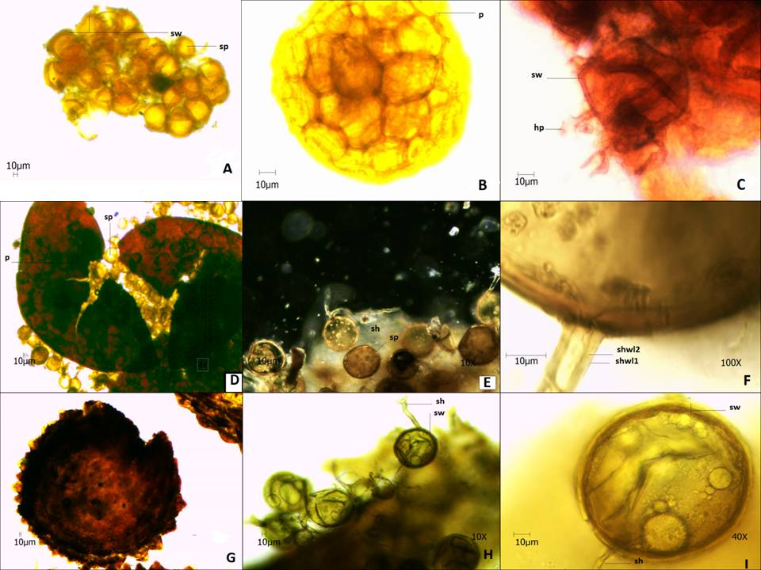
a-c Sclerocystis sinuosum b. Divrsispora aurentia and Glomus sp. (where sp- spore, p-peridium, sw-sporewall, sh- subtending hyph, a shw1 and shw2 - subtending hyphae wall layers).

APPENDIX 3
Values of mean and standard errors for different soil environment parameters

UD group |  | pH | soil moisture | temp | % C | % N | P (PPM)
gp1 | Mean | 8.17a | 11.16a | 13.33 | 37.29a | 0.06a | 26.70a
 | SEM | 0.06 | 0.14 | 0.12 | 36.22 | 0.00 | 1.04
gp2 | Mean | 8.01b | 10.04b | 13.33 | 0.78a | 0.05b | 20.37b
 | SEM | 0.02 | 0.22 | 0.05 | 0.02 | 0.00 | 1.70
gp3 | Mean | 6.35c | 18.94c | 16.00 | 0.47a | 0.05b | 9.34c
 | SEM | 0.09 | 1.39 | 0.00 | 0.02 | 0.00 | 0.42
Letters indicate statistical difference according to Tukey’s HSD multiple comparison tests.

APPENDIX 4

Maximum likelihood phylogenetic tree based on nuclear small subunit full (SSU)-5.8S-large subunit (LSU) rDNA of sequences isolated in present study and selected sequences of species from Glomeromycota

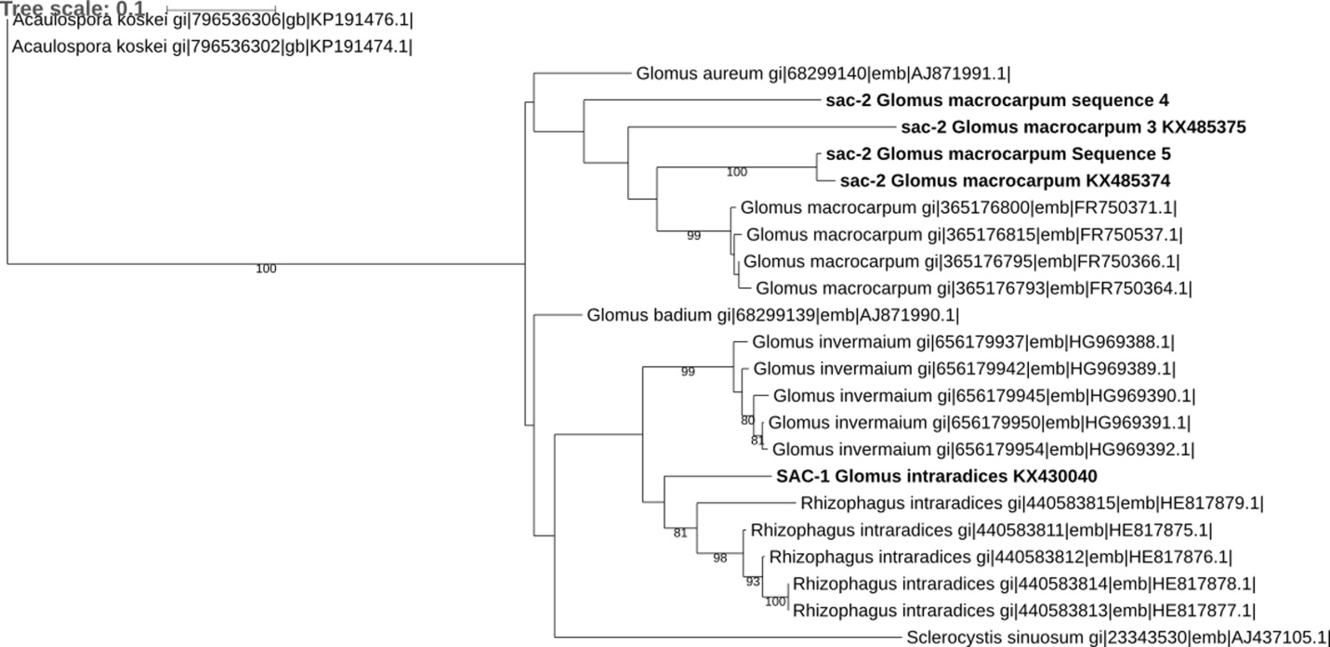
Bootstrap values are given for branches among different NCBI accession numbers. Acaulospora koskei sequences were used as outgroup. Multiple sequence alignment was done with Clustal w and phylogenetic tree was drawn with RaXml. The scale bar indicates the number of substitutions per site. Branches with < 60 % bootstrap support were collapsed to polytomies, The scale bar indicates the number of substitutions per site. Treeview 1.6.6 is used for drawing the tree.

APPENDIX 5
Effect of urban disturbance on spore density (A) and (MIP) of AM fungi isolated from nine sites located at Delhi Ridge

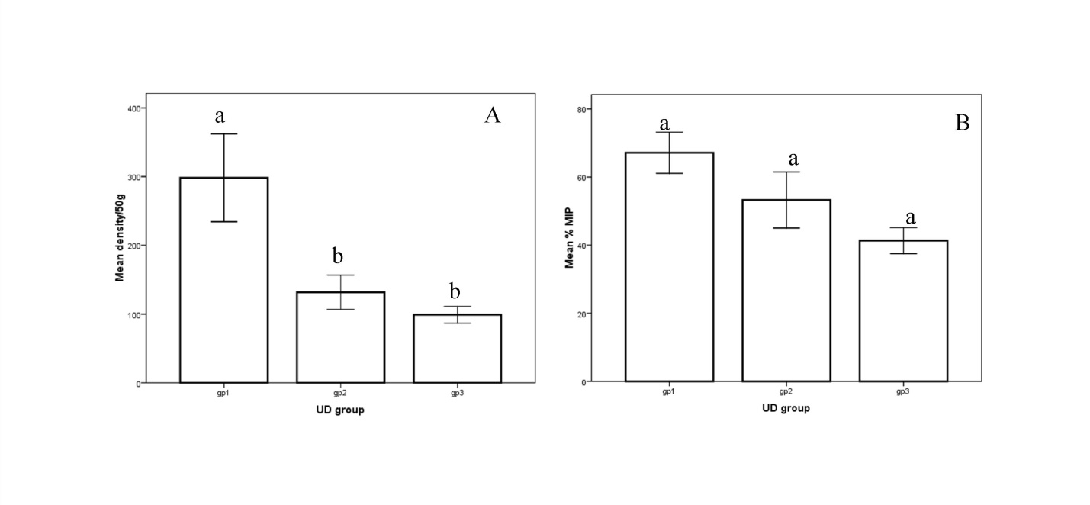

APPENDIX 6
Venn diagram (plotted on the basis of presence absence of species) depicting distribution of Glomeromycotean species within three UD groups

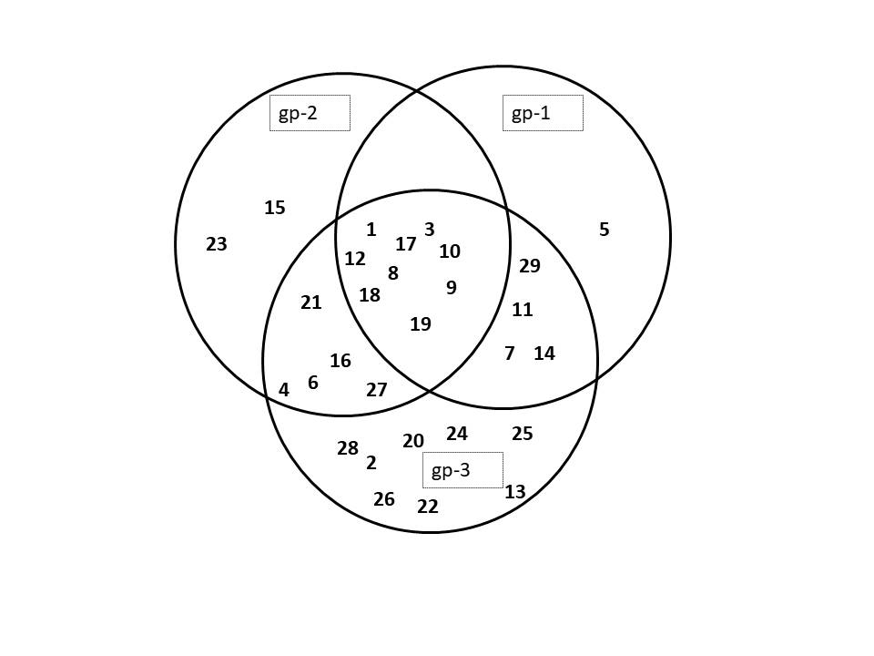
1-Glomus microaggregatum N. C. Schenck & G. S. Sm; 2- Glomus microcarpum Tul. & C. Tul {= Endogone microcarpa (Tul. &C. Tul.) Tul. & C. Tul. =Endogone neglacta Rodway}; 3- Glomus sp1; 4-Unidentified sp2; 5-Unidentified sp5; 6-unidentified sp.1; 7-Glomus invermianum R. Hall; 8-Diversispora aurantia (Blaszk., Blanke, Renker & Buscot) C. Walker & A. Shussler (= Glomus auronatium Blaszk., Blanke, Ranker & Buscot); 9-Rhizophagus aggregates (N.C. Schenck & G.S. Sm.) C. Walker; 10-Glomus ambisporum (G.S. Sm. & N.C. Schenck); 11-Glomus sp2; 12-Glomus tenebrossum S.M. Berch (=Endogone tenebrosa Thaxt.); 13-Rhizophagus intraradices (N.C. Schenck& G.S. Smith) C. Walker & A. Schüßler); 14-Unidentified sp3; 15-Unidentified sp4;16-Rhizophagus fasciculatus (C. Walker & A. Schüßler); 17-Glomus macrocarpum Tul.& C. Tul; 18-Enterophospora sp. (R. N. Ames & R.W. Schneid); 19-Entrophospora infrequens (I.R. Hall ) R.N. Ames & R.W. Schneid.(= Glomus infrequens I.R. Hall); 20-Glomus albidum C. Walker & L.H. Rhodes; 21-Glomus austral Berk.) S.M. Berch (= Endogon eaustralis Berk.); 22-Funneliformis geosporum T.H. Nicolson & Gerd.) C. Walker & A. Schüßler; 23-Funneliformis mosseae T.H. Nicolson & Gerd.) C. Walker & A. Schüßler; 24-Acaulospora sp.; 25-Acaulospora laevis Gerd & Trappe; 26-Scutellospora calospora (T.H. Nicolson & Gerd) C. Walker & F. E.; 27-Glomus constrictum (Trappe); 28-Gigaspora sp.; 29-Gigaspora gigantean (T.H. Nicolson & Gerd.)

